Tym Lawrence
Sample Articles

Data Maturity Assessment offering

Overview
Tym developed a Data Maturity Assessment, aimed at enhancing your organization's use of customer data.

Using the world’s leading data assessment framework and a custom AI system, he’ll examine your current customer data capabilities, identify areas for improvement, and offer actionable steps to increase customer satisfaction and drive revenue.

Benefits of Customer Data Maturity
Data maturity, especially for customer data, is crucial to optimize decision-making, enhance customer experiences, and achieve operational efficiency. Mature data practices lead to:
- Better Decision-Making: Move from intuition-based to insight-driven strategies.
- Increased Revenue: Leverage customer data for effective upselling and cross-selling.
- Improved Customer Satisfaction: Anticipate and meet customer needs to foster loyalty.
- Improved Efficiency: Reduced risk and costs by improving data quality and secure access.

What You’ll Get
You'll receive a comprehensive report including:
- An executive summary detailing your data management landscape and maturity levels.
- A detailed analysis of your capabilities across key data management areas.
- A list of prioritized, actionable recommendations for immediate improvement

Our Approach
The Return on Customer Data Assessment is structured around three or four workshops, run at a time that is convenient to you.

Workshop 1: Strategic Use of Customer Data
A 1 hr session with all groups, covering:
- Topic 1: Value and Return on Customer Data
- Topic 2: Analytics, AI and Automation

Workshop 2: Customer Data Governance & Design
An optional 1.5hr session with data management team, covering:
- Topic 3: Data Governance
- Topic 4: Data Architecture
- Topic 5: Data Modelling & Design

Workshop 3: Customer Data Quality and Completeness
A 1.5 hour session with data and customer experience teams, covering:
- Topic 6: Data Quality
- Topic 7: Documents & Unstructured Content
- Topic 8: Reference & Master Data
- Topic 9: Metadata

Workshop 4: Operational Excellence in Customer Data
A 1.5 hour session with IT and data management teams, covering:
- Topic 10: Data Security & Privacy
- Topic 11: Data Infrastructure, Storage & Operations
- Topic 12: Data Integration & Interoperability

Who should be involved?
Workshops should involve stakeholders from different areas for a comprehensive and well-rounded view. Key personnel include:
- Executives and senior decision-makers such as CDO, CIO or CMO.
- Customer Experience and Marketing Professionals responsible for delivering exceptional customer experiences and targeted marketing messages.
- Data Analysts and Scientists who use customer data to provide insights for business strategies.
- Data Management Professionals overseeing the quality, integrity, and security of data.
- IT Professionals involved in the delivery and maintenance of data management systems.

Transform Your Data Management
The Return on Customer Data Assessment is more than just an analysis—it's a roadmap for leveraging your customer data to its fullest potential.
With our expert recommendations, you can streamline your data management processes, enhance customer engagement, and drive significant business growth.The capability maturity assessment is be based on the DAMA-DMBOK2 framework, which is the world’s leading framework to assess data maturity, with the addition on some extra topics to provide a stronger focus on the use of customer data.

Session Details

Session 1: Customer Data Activation
- Duration: 1 hour
- Agenda
  - Introduction
    - Engagement purpose and deliverables
    - Overview of next sessions
  - Questions and discussion on the following topic(s):
    - Topic 1: Value and Return on Customer Data – looking at how the company using customer data right now and what the future might look like if we could use data to improve the customer experience.
    - Topic 2: Analytics, AI and Automation – looking at access to reporting and analysis of customer data, as well as the use of customer data for Data Science / AI / machine learning, segmentation, personalisation and marketing automation.
- Requires attendees from all groups:
  - Executives
  - Customer Experience, Content & Marketing Professionals
  - Data Analysts and Scientists
  - Data Management Professionals
  - IT Professionals

Session 2 (Optional): Data Governance and Design
- Duration: 1.5 hours
- Agenda
  - Introduction and recap of previous sessions
  - Questions and discussion on the following topic(s):
    - Topic 3: Data Governance – planning, oversight, and control over management of customer data and the use of data and data-related resources.
    - Topic 4: Data Architecture – the overall structure of customer data as part of the enterprise data architecture.
    - Topic 5: Data Modelling & Design – analysis, design, building, testing, and maintenance of customer data.
  - Overview of next session
- Requires attendees from these groups:
  - Data Management Professionals
- Optional attendees:
  - Executives – Eg CDO
  - Data Analysts and Scientists

Session 3: Customer Data Quality and Completeness
- Duration: 1.5 hours
- Agenda
  - Introduction and recap of previous sessions
  - Questions and discussion on the following topic(s):
    - Topic 6: Data Quality – defining, monitoring, maintaining data integrity, and improving customer data quality.
    - Topic 7: Documents & Unstructured Content – storing, protecting, indexing, and enabling access to customer data found in unstructured sources (electronic files and physical records), and making this data available for integration and interoperability with structured (database) data.
    - Topic 8: Reference & Master Data – Managing the shared ‘golden record’ of customer data to reduce redundancy and ensure better quality.
    - Topic 9: Metadata – collecting, categorizing, maintaining, integrating, controlling, managing, and delivering metadata (the data about the customer data).
- Requires attendees from these groups:
  - Customer Experience, Content & Marketing Professionals
  - Data Analysts and Scientists
  - Data Management Professionals
- Optional attendees:
  - IT Professionals

Session 4: Operational Excellence in Customer Data
- Duration: 1.5 hours
- Agenda
  - Introduction and recap of previous sessions
  - Questions and discussion on the following topic(s):
    - Topic 10: Data Security & Privacy – ensuring privacy, confidentiality and appropriate access to customer data.
    - Topic 11: Data Infrastructure, Storage & Operations - underlying infrastructure and structured physical storage deployment and management of customer data. Includes Data Warehousing and CPD systems for managing analytical processing.
    - Topic 12: Data Integration & Interoperability – acquisition, extraction, transformation, movement, delivery, replication, federation, virtualization and operational support for customer data
- Requires attendees from these groups:
  - Data Management Professionals
  - IT Professionals
- Optional attendees:
  - Data Analysts and Scientists

Deliverables
Once the information has been gathered a report will be prepared with the following content:
- Executive summary with an overview of current state as seen in a customer data landscape map and capability overview diagram, plus a summary of recommendations / next steps
- Capability maturity level analysis of each topic with recommendations to address gaps

Sample Insights Paper Proving the ROI of CX

Part 1 – Research Review

Introduction
Conversations I’ve had with Customer Experience (CX) practitioners often circle back to the question:
“How do we show the connection between the value of our CX program and real business returns?”
This 3-part article aims to answer that question through a quick look at the research (Part 1), a summary of case studies I heard at the Customer 360 Symposium in March 2023 (Part 2) before outlining seven essential steps to connect CX improvements into measurable business returns (in Part 3).
So, on to part 1, which provides a quick review of the research on the measurable improvements in customer loyalty, revenue growth, and cost efficiencies that come from investing in high-quality CX initiatives.

Watermark Customer Experience ROI Study
A long-term analysis by Watermark Consulting vividly demonstrates the financial benefits of CX leadership. For over a decade, Watermark’s annual CX ROI study has compared stock returns of CX leaders and laggards (as identified by third-party rankings such as Forrester and Qualtrics) across industries.
The 2021 version of the The Customer Experience ROI Study by Watermark Consulting highlights the stark contrast between CX Leaders and Laggards in terms of stock market performance.
The graph (above) shows the cumulative total return across a 13-year period. Some key findings:
CX Leaders outperform the market, generating a return 108 points higher than the S&P 500 Index.
CX Laggards post a return that is 110 points lower than the S&P 500 Index.
CX Leaders generate a cumulative return 3.4 times greater than CX Laggards.
This study not only tracks stock performances but also explains the underlying reasons for superior financial results among CX Leaders:
CX leaders generate higher revenue. Satisfied and loyal customers exhibit better retention, are less sensitive to price fluctuations, and are more inclined to consider additional products and services, all of which contribute to increased revenue. Moreover, their enthusiasm results in positive word-of-mouth and referrals, further boosting revenue.
CX leaders also achieve higher cost efficiencies. hey experience fewer customer complaints and lower service costs, leading to smoother operations and enhanced profitability. Additionally, customer referrals reduce the costs associated with acquiring new customers.

Harvard Business Research
In a 2014 Harvard Business Review (HBR) article, Medallia examined sector-specific data to shed more light on the direct impact of CX. They looked at both subscription-based and transactional models, and the effect of positive CX encounters on drive repeat purchases and increased customer spending:
- Transactional Models: After accounting for other factors influencing repeat purchases (e.g., frequency of customer need for the company's goods and services), customers who had the best past experiences spent 140% more compared to those with the poorest past experiences.
- Subscription Models: A member rating their experience as the poorest has only a 43% chance of remaining a member a year later. In contrast, a member who gives one of the top two experience scores has a 74% chance of continuing their membership for at least another year.
- Predicting Future Membership: Medallia used this data to predict future membership duration based on experience quality. On average, a member who gives the lowest score is likely to remain a member for just over a year. Conversely, a member who gives the highest score is likely to stay for another six years.
These metrics underscore the dual benefit of investing in CX—boosting revenue while simultaneously driving down costs. The Medallia research emphasises that “delivering great experiences actually reduces the cost to serve customers from what it was previously”. They write:
Systematically solve the source of dissatisfaction, you don’t just make them more likely to return — you reduce the amount they cost you to serve. For example, Sprint has gone on record as suggesting that as part of their focus on improving the customer experience, they’ve managed to reduce their customer care costs by as much as 33%.
Indeed, more recent research from Harvard Business School underlines the economic advantage of customer retention, showing that even a 5% increase in customer retention correlates with at least a 25% increase in profit.

Other Studies
Dimension Data’s 2017 Global Customer Experience Benchmarking Report found
- 84% of companies that actively enhance their CX report an increase in revenue,
- 92% of companies see increased customer loyalty
- 79% see cost savings.
Similarly, the American Express 2017 Customer Service Barometer found that American consumers are willing to pay up to 17% more for a product or service if the company provides excellent customer service.
For additional compelling evidence, the Australian Customer Experience Professionals Association (ACXPA) offers an extensive list of Customer Experience Statistics to Use at Work. The CX Impact on Revenue and Business Growth section provides numerous research-based statistics that underscore the financial benefits of investing in CX. Here are some key highlights:
- Revenue Increase: Companies that prioritize CX see an impressive 80% increase in revenue (Zippia).
- Budget Allocation: Organizations that demonstrate a clear connection between customer satisfaction, growth, margin, and profitability are 29% more likely to secure additional CX budgets (Gartner).
- Customer Lifetime Value: Businesses with superior CX enjoy a customer lifetime value that is 600% to 1400% higher than that of detractors (Bain & Company).
- Revenue Growth: CX leaders achieved more than double the revenue growth of CX laggards between 2016 and 2021 (McKinsey).
- Spending Behaviour: Customers are willing to spend up to 140% more after a positive experience compared to those who report negative interactions (Deloitte).
- Revenue Loss: Poor CX can lead to an average revenue loss of 9.5%. Research by Qualtrics across 17 different industries shows that even a single bad experience can significantly impact revenue (Qualtrics).

Conclusion
In this Part 1, we’ve seen that the research consistently shows that investment in high-quality CX not only pays for itself but also provides competitive advantages in market positioning and financial performance. Businesses leading in CX not only recoup their investment but also achieve superior returns, showcasing the strategic value of exceptional customer experiences.
Part 2 will look at three case studies from the Customer 360 Symposium in March 2024 which makes this research real.

Part 2 - Australian Stories

Introduction
Customer Experience (CX) is increasingly recognized as a critical differentiator in the marketplace. For businesses aiming to drive significant results, understanding the nexus between customer experience and business value is imperative.
This 3-part article aims to understand that nexus through a quick look at the research (Part 1), a summary of case studies I heard at the Customer 360 Symposium in March 2023 (Part 2) before looking at the seven essential steps to showcase how CX improvements translate into measurable business returns (in Part 3).
In late March 2024, I attended the Customer 360 Symposium. This two-day conference features presentations from numerous Australian companies who had successfully linked customer experience (CX) enhancements to tangible business metrics.
These presentations provide practical insights into the strategic integration of CX initiatives with broader business goals along with effective strategies for securing executive buy-in and addressing longstanding customer service challenges.

Three noteworthy presentations are detailed below, based on notes I took during the summit.

Think Customer – Demonstrating Value
from CX Transformation

Tom Bradley, GM Customer Experience, Kmart
To understand the critical role of CX in business success, Kmart collaborated with an external agency to analyse their Net Promoter Score (NPS) data. This analysis uncovered a direct correlation between high NPS scores and increased customer spending, providing a clear financial perspective on the value of customer satisfaction.
“We could go to the MD and say ‘NPS is more important than you though’. We can show you, down to the dollar, where it adds value.
Connecting NPS to value was a real unlock.”
The company then did a driver analysis on what made the NPS move. The most important factors:
- Product availability. As stated by the presenter: “Making sure product was available was more important than having someone smile at you or shorter checkout.”
- Service experience and interacting with staff
- Checkout and exit experience
Armed with this data, Kmart could effectively communicate the business impact of CX to its executives, securing necessary buy-in for bringing together a cross functional team and making targeted investments focused on enhancing customer service and product availability.
One of the first steps was to assemble a unified team to enhance the impact of customer insights. The integration involved merging disparate research and voice of the customer (VOC) functions from marketing, including online and store research, into a cohesive group. This unified team also brought together customer service from online platforms and service designers from various business units.
Previously, Kmart's customer, marketing, and online analytics were fragmented. By centralizing these functions, the company could leverage its strong research capabilities more effectively, which previously got diluted when crossing into analytics.
Similarly, the customer service function, though well-run, was underutilized. By carving out and elevating this group into the CX design team, Kmart created a balanced mix of individuals who not only understood the business intricacies but were also adept at designing services.
However, merely congregating these functions was not sufficient. So, Kmart's CX team shifted from a passive approach of delivering reports and insights to actively embedding the customer perspective at the heart of decision-making processes. This positioned the customer experience team on equal footing with traditional core functions like operations and finance, thereby ensuring that customer insights factored into business strategies directly.
Cross-team collaboration was essential to success. One example given was where operations deployed robots in stores for accurate stock checks and replenishment - and so helped deliver a crucial element to customer satisfaction: ensuring product availability. Indeed, these operational enhancements, more than anything,
improved NPS.By improving stock availability and making other CX investments, Kmart improved the shopping experience across both digital and physical platforms. These initiatives not only addressed key customer pain points but also strengthened Kmart’s overall market position.


Leveraging Customer Insights to Uncover Growth Opportunities and Drive Business-Wide Change

Candice Liew, Head of Customer Strategy and Experience, Flybuys
FlyBuys is a leader in customer loyalty programs. Their presentation explored their transformative approach to leveraging customer experience (CX) and insights to resolve longstanding business challenges and foster substantial growth.
With a legacy of overwhelming insights and substantial hours spent on reporting, FlyBuys found itself at a crossroads, needing a significant shift to align insights more effectively with actionable business outcomes.
The company embarked on a journey to redefine their focus towards member engagement, shifting from merely increasing membership numbers to enhancing the engagement and activity levels of existing members.
This shift was grounded in the understanding that value for FlyBuys - and their members - only materialises when members are actively participating in the program. So, they began by defining engagement into four main groupings, each associated with specific parts of the member experience:
1. Earning standard points
2. App usage
3. Offer activation and bonus points
4. Redemption
Building on this structured engagement model, FlyBuys was able to show a clear correlation between engagement levels and business value. This enabled a more targeted approach to improving the CX and interactions that directly influenced engagement levels.
This approach “Flipped the narrative and elevated pain points onto the roadmap”.
By elevating these issues to strategic priorities and integrating them into the business roadmap, were able to prioritise CX initiatives that had been previously overshadowed by other growth strategies.
 | From | To
Enterprise Strategic Priority | Membership growth  Financial outcomes | Member engagement  Doing the basics well
Longstanding legacy CX issues | Deprioritised against traditional growth initiatives | Now a top strategic priority
Customer insights | Discuss within teams | Now a regular topic amongst Executives and Senior leadership
This case study exemplifies the importance of aligning CX initiatives with business outcomes and the powerful impact of engaging leadership through a blend of emotional and financial insights. FlyBuys’ experience highlights how a strategic focus on member engagement can transform customer insights into meaningful, value-driving actions within a business.



Beyond Screens: Foxtel’s Quest Toward Integrated CX Insights
Presentation by Simon Stevens, Director, Group Research, Foxtel
Foxtel, a leader in the Australian media landscape, has embraced a data-driven transformation to enhance customer experience (CX) across its suite of services, including Foxtel, Binge, Kayo (sports streaming), and Flash (news streaming).
Simon Stevens, the presenter, started by noting that the Group Research team brings together different insights functions and disciplines to give more wholistic view.
This team also spearheaded efforts to blend various data streams—traditional market research, Voice of the Customer feedback (collected through InMoment), and audience / rating data—to craft a unified view of the customer experience. This approach went beyond typical data aggregation, incorporating advanced analytics to drive actionable insights and predict value improvements across all customer touchpoints.
One of the team's key achievements was establishing a correlation between Net Promoter Score (NPS) and customer churn rates. By demonstrating that improvements in NPS were directly linked to reduced churn, Foxtel provided a compelling business case to gain executive buy-in for CX initiatives. They also used driver analysis to show linkages and impact. For instance, exploring the impact the viewing app has on NPS.
Armed with this understanding, Foxtel could show the benefit in targeting longstanding CX pain points that had been previously overshadowed by other business priorities. This shift not only addressed immediate CX issues but also positioned Foxtel as a customer-centric organization in a competitive digital market.
Some key takeaways:
- Align Insights with Business Objectives: Begin by thoroughly understanding business objectives to ensure that the insights gathered are directly aligned with business needs.
- Embrace Adaptability: Maintain flexibility in strategies and approaches to effectively integrate new insights and adapt to changing market conditions. Recognize that improvement is an ongoing process: Change is never done.
- Engage Across the Business: Secure the involvement of wider business functions such as IT, Finance, and senior leadership to provide critical decision support and facilitate the practical application of insights.
- Benchmark Broadly: When evaluating best practices, extend the search beyond your immediate industry to include insights and strategies from varied sectors for a broader perspective. For instance, Simon Stevens gained valuable insights from the travel industry through Tui, and partnerships like InMoment brought cross-industry knowledge into play.
- Focus on Moments that Matter. For the new Hubbl service, they did extensive journey mapping and qualitive research to understand what customers expected and what would matter to them.
- Insight to Action: Dedicate significant effort to not just creating insights but ensuring they are actionable. This focuses on the consultancy aspect—aiding decision-makers in implementing changes that make a measurable difference.
Ultimately, Foxtel’s approach resulted in a more engaged customer base, evidenced by enhanced usage of their platforms and increased customer loyalty.

Conclusion
The research we saw in Part 1 is backed up by the three ANZ stories from the Customer 360 Symposium:
- Kmart: Demonstrated a direct correlation between high NPS scores and increased customer spending, which provided clear financial justification for prioritizing CX transformations.
- Flybuys: Leveraged customer insights to shift focus to enhancing member engagement, which significantly amplified the value derived from active participants.
- Foxtel: Established a direct link between improved Net Promoter Scores (NPS) and reduced customer churn rates, facilitating executive buy-in for CX initiatives by correlating them with tangible reductions in customer turnover.
In Part 3, I’ll run through my take on the 7 key steps that CX practitioners should take.

Part 3 - Steps to Success
This 3-part series has sought to answer the question: How do we show the connection between the value of our CX program and real business returns.
In Part 1 we looked at the extensive body of research that show a well-executed customer experience strategy can positively influence stock prices, enhance customer loyalty, drive revenue growth and decrease costs. In Part 2, we saw three practical examples of this through the success stories of Kmart, Flybuys and Foxtel.
In this part, I’ve identified 7 essential steps to take to not only improve customer experience and satisfaction but also strengthen the market position and overall financial health of the organisation.

Before You Begin
I should note that the seven steps assume you already have:
A CX person or team with the mandate to improve the overall customer engagement.
An Experience Management Platform (eg Qualtrics, Medallia or InMoment) for gathering customer feedback - ideally across multiple touchpoints including post purchase, in-store, call centre, website, app etc.
Sufficient historical quantitative and qualitative data available for analysis. What is sufficient will vary depending on what you are trying to understand.
If these are missing, then you might need to get the foundations in place first.

1. Executive Sponsor and Cross-Functional Team
Effective CX requires the collaboration of diverse teams across the organization, including:
Customer Service Teams: Ensuring every customer interaction adds value.
Research/Voice of the Customer (VoC) Teams: Gathering and analysing customer feedback.
Service Designers: Designing the services to meet customer needs across various touchpoints.
Data and Analytics Teams: Integrating and interpreting customer data.
Marketing and Sales: Utilising insights to enhance customer acquisition and retention.
Finance and Operations: Aligning CX with financial outcomes and operational efficiencies.
As seen in the Kmart story, these teams each contribute different perspectives, helping to create a holistic view of the customer journey and align CX objectives with broader business goals. This cross-functional approach ensures that all areas of the business are focussed on improving customer satisfaction in a way that is aligned with broader business outcomes.
Most successful examples of a CX program also have strong executive level sponsorship, something that will be easier to obtain after step 4, below.

2. Bring Together Quantitative Data and Qualitative Insights
Merging quantitative data with qualitative insights provides a full spectrum view of CX. Quantitative data offers insights into what is happening, such as sales figures or service usage stats, while qualitative data explains why it's happening, based on customer scores and verbatim feedback.
This might include Integrations with your data warehouse or systems like Salesforce, ServiceNow, Zendesk, Adobe Analytics, Google Analytics and so on. To do this, you might use a Data Virtualisation solution (from TIBCO or Denodo) and/or cloud-based data warehouse systems like Snowflake, Amazon Redshift, Google BigQuery or Microsoft Azure Synapse, perhaps combined with a big data processing analytics platform like Databricks or Apache Spark which can process data science models.
Speaking of data science, if you haven’t already done so, this would be the right time to look at implementing AI and Natural Language Processing (NLP) text analytics for large-scale identification and tagging / coding of the sentiment, products, actions, themes and so on that is found in the feedback.
Some examples of this mentioned in this paper:
Kmart: Analysed NPS scores alongside transaction data to identify how positive experiences correlate with increased spending and return visits.
Foxtel Integrated customer feedback with actual usage data to explore the reasons behind customer churn. They brought together traditional market research data, audience / ratings data and customer experience / VOC feedback from In-Moment. Soon they will start bringing in unstructured data, such as social media feeds, and getting this Experience Management Platform to apply the same coding scheme used for other data so they have consistent and holistic feedback across all customer signals.

3. Confirm Your Customer Experience Metrics
Selecting the right metric(s) is crucial for accurately assessing CX. Metrics like NPS, CSat, OSAT, or custom indices like "Customer Engagement" should be clearly defined and understood across the business and consistently applied all customer interactions. This standardization helps in benchmarking performance and understanding the impact of CX initiatives on the customer's experience.
Some examples mentioned in this paper:
Foxtel: Utilised Strategic Net Promoter Score (NPS) to measure CX not just within the company but also relative to the industry, helping to highlight performance against competitors.
Flybuys: Chose member engagement as the metric, focusing on how engaged members interact with the platform and the resulting impact on loyalty and revenue.
You might go deeper and look at subsets of NPS, such as:
TNPS (Transactional Net Promoter Score) asking how likely they are to recommend the company based on that transaction. This measures customer satisfaction based on specific interactions or transactions to gauge the immediate response of customers to a service or product.
RNPS (Relational Net Promoter Score): This score evaluates the overall relationship between a customer and a company over time. It assesses customer loyalty and overall satisfaction over the entire customer experience, not just based on a single interaction.

4. Use Unified Data to Identify Causal Connections and Prove Value
Analysing unified data to find causal links between CX initiatives and business outcomes is essential for justifying CX investments. Techniques like regression analysis can pinpoint which CX improvements drive key business metrics. Predictive modelling can also be also used to project potential revenue increases, or cost savings, from incremental increases in your customer experience metric.
Quantifying the financial impact of CX improvements is then key to securing executive support. Demonstrating how CX metrics influence financial outcomes—such as revenue growth or cost savings—can help executives see the tangible benefits of investing in CX, ensuring continued support and resource allocation.
Some examples:
FlyBuys: Identified that “fully engaged” members could deliver up to 15 times more value compared to less engaged ones, allowing them to show how much additional value the member, partner and Flybuys could all earn by helping members to becoming ‘fully engaged”.
Kmart: Presented data linking NPS scores to revenue, successfully gaining the support of senior management to address CX issues.

5. Conduct Driver Analysis to Understand what Moves Your Metric
Driver analysis helps identifies the specific elements of CX that most significantly impact overall customer satisfaction and business performance. Understanding these drivers allows organizations to target improvements more effectively and allocate resources where they will have the greatest effect on customer loyalty and financial returns.
Kmart: Used driver analysis to that product availability on shelf has the largest impact on NPS
Foxtel: Used driver analysis to link the viewing app's performance with NPS, providing a focused area for improvements.

6. Prioritise and Address Key Pain Points that Move Your Metric
Based on the understanding of what drives impact on your CX metric, you can more easily identify the CX pain points that affect customer satisfaction. Simply ask, as Kmart did: “How much is it worth to fix pain points?”
Once you know what needs to be fixed to get the biggest benefits, then, of course, you must do the work to actually fix the issue(s). Here you leverage through all the tools available to a CX professional, from personas and journey mapping to a full website or app update.
By identifying and addressing these prioritised issues, companies can enhance the customer journey, reduce churn, and improve operational efficiency.
Some examples of this:
Kmart: Addressed the main pain point of product availability by using operational interventions that customers do not see, such as automated stock replenishment systems.
Flybuys: Focused on resolving minor annoyances that were hindering member engagement, thereby improving the overall customer experience and helping members become fully engaged.

7. Embed Customer Experience in the Culture and all Decision Making
Incorporating CX into the organisation’s culture and strategic decision-making will take time, but it ensures a sustained focus on customer needs across the business. This ongoing commitment helps align customer metrics with operational performance and reinforces the role of CX in achieving business goals
Some tips on doing this from the stories in this paper:
Intentionally move from more passive function (eg delivering reports and insights) to becoming more proactive and participating in decisions on equal footings with other groups like operations and finance.
Be sure that your customer experience metrics (eg NPS) are, and stay, aligned with operational metrics (eg the stock on shelf metric, used by Kmart)
Ensure that organizational Key Performance Indicators (KPIs), including those for the executive team, reflect the importance of CX metrics. Several organisations at the Customer 360 Symposium noted that NPS was a key KPI for the executive team.
Continue to demonstrate value anytime you can. Continue to your insights and data to find quick wins that increase your CX metric and so bring business returns.

Conclusion
Part 1 showed the strong connection between CX investments and ROI. Part 2 gave local case studies which make the research real. In this part, I’ve tried to distil down what I’ve heard from industry leaders into 7 essential steps to measure and prove the financial benefits of CX initiatives, supported by examples from the case studies.
My hope is that, together, these 3 parts provide a complete answer to the question I heard at many conferences: How do we show the connection between the value of our CX program and real business returns?

Sample Insights Paper – From Data to Decisions: Shaping Your Data-Driven Future with the Return on Customer Data Assessment
In an era where data is often described as the new oil, the ability to sift through this digital wealth to fuel strategic decisions remains a formidable challenge for many businesses. The journey from raw data to actionable insights is fraught with complexities and uncertainties that can deter even the most ambitious leaders. However, the pathway to a data-driven future is not as labyrinthine as it might seem, thanks to structured methodologies like the Return on Customer Data Assessment. This article explores how this assessment can act as a strategic partner to businesses, especially those hesitant to invest in data projects due to uncertainties about outcomes or returns.

The Untapped Potential of Data in Strategic Decision-Making
Data, in its raw form, holds the potential to revolutionize businesses by uncovering insights that can lead to better decisions, enhanced customer experiences, and ultimately, a significant competitive edge. The transformative power of data is not just in its collection but in its analysis and application. Yet, the gap between collecting data and leveraging it for strategic decision-making remains wide, with many businesses struggling to bridge this divide.

Overcoming Hurdles: From Data Collection to Actionable Strategies
The journey from data to decisions is riddled with hurdles. These range from technical challenges, such as the integration of disparate data sources, to cultural ones, like fostering a data-driven mindset across the organization. The complexity of data itself, with its volume, velocity, and variety, adds another layer of difficulty in deriving meaningful insights. Moreover, the uncertainty of outcomes or returns from data projects can make decision-makers hesitant to make the necessary investments.

The Role of the Return on Customer Data Assessment
Enter the Return on Customer Data Assessment, a tool designed not just to evaluate but to guide businesses on the journey towards becoming truly data-driven. This assessment, based on the DAMA-DMBOK2 framework, does more than pinpoint where a company stands in terms of data maturity. It provides a customized roadmap that details specific steps a business can take to leverage its customer data effectively​​.

A Customized Roadmap for Success
The Assessment process is thorough, involving workshops and interactive sessions that delve into various aspects of data management, including governance, quality, security, and the strategic use of analytics and AI​​. By focusing on the company's unique challenges and opportunities, the Assessment delivers tailored recommendations that demystify the process of turning data into strategic decisions.

Success Stories: The Impact of Preliminary Assessments
The effectiveness of the Return on Customer Data Assessment is best illustrated through success stories. Businesses that have undertaken this assessment often find that the roadmap provided not only clarifies the steps needed to harness the power of their data but also aligns their teams around a common data-driven mission. These success stories underscore the role of preliminary assessments in breaking down barriers to data utilization, fostering a culture of innovation, and driving tangible business improvements.
NEED MORE HERE>

Inspiring Confidence in Data-Driven Strategies
For decision-makers hesitant about the value of data projects, these success stories serve as a powerful testament to the transformative potential of a structured approach to data management. The Return on Customer Data Assessment not only lays out a clear path to leveraging data but also builds confidence in the strategic importance of data-driven decisions.

Conclusion: The Catalyst for Change
The journey from data to decisions need not be daunting. With the Return on Customer Data Assessment, businesses have a strategic partner that offers a clear, customized roadmap for harnessing the potential of their customer data. This assessment is more than an evaluation tool; it is a catalyst for change, demystifying the process of leveraging data for business success and inspiring confidence in data-driven strategies.
For businesses on the fence about investing in data projects, the message is clear: the potential rewards far outweigh the perceived risks. By understanding your current position in the data maturity journey and leveraging the insights and roadmap provided by the Return on Customer Data Assessment, your business can embark on a transformative journey toward making insightful, data-driven decisions that propel you ahead of the competition.
In a world where data is king, understanding how to mine and utilize this digital currency is crucial. The Return on Customer Data Assessment not only highlights the strategic importance of data but also offers a clear path toward improvement. For businesses looking to navigate the complexities of the digital age, it is an invaluable first step towards a data-driven future.

Sample Insights Paper - Data Transformation Needs a Baseline: Unveiling the Unknown with a Return on Customer Data Assessment
In the age of information, understanding and leveraging customer data has become a linchpin for business success. Yet, many organizations navigate this digital terrain with a significant blind spot: an accurate understanding of their actual capabilities and limitations in utilizing this goldmine of insights. This gap, often filled with "unknown unknowns," can significantly impede strategic decision-making and growth. Herein lies the value of establishing a clear, objective baseline of an organization's data maturity— a foundational step that the Return on Customer Data Assessment facilitates with precision.

The Bedrock of Transformation: Establishing a Clear Baseline
Embarking on a data-driven transformation without a clear baseline is akin to setting sail without a compass. The baseline serves as the critical starting point from which all improvements and strategic planning initiatives are measured. It's not merely about understanding where you stand; it's about laying the groundwork for where you can go. Without this clarity, efforts to evolve and enhance data capabilities can be misdirected or, worse, entirely futile.

Navigating the Unknown Unknowns
The realm of customer data utilization is fraught with "unknown unknowns" – gaps in strategy and execution that businesses aren't even aware exist. These are the blind spots that can hide significant inefficiencies or obscure potential opportunities for growth and enhancement. For instance, an organization might collect extensive customer data but fail to leverage it for personalized marketing strategies due to unrecognized gaps in data integration and analysis capabilities.

The Power of the Return on Customer Data Assessment
The Return on Customer Data Assessment acts as a beacon, illuminating the landscape of an organization's data management practices. It meticulously maps out the current state of data maturity, offering a comprehensive view that extends beyond surface-level understandings to uncover hidden challenges and opportunities. By examining key areas such as data governance, quality, security, and the strategic use of analytics and AI, the Assessment provides insights that can transform an organization's approach to customer data.

Transformation Tales: From Insight to Action
Consider the hypothetical case of a mid-sized retail company with a burgeoning online presence. The company has invested in collecting customer data but hasn't seen the expected uptick in engagement or sales. A Return on Customer Data Assessment reveals a crucial oversight: the data collected isn't being effectively segmented or analyzed to inform marketing campaigns. Armed with this insight, the company restructures its data analysis process, integrates advanced analytics tools, and launches targeted marketing campaigns that significantly boost customer engagement and sales.
Another scenario involves a financial services firm struggling with customer retention. The Assessment uncovers that the firm's data security measures are not up to industry standards, leading to customer apprehension and churn. By addressing these security gaps and communicating these enhancements to its customers, the firm not only bolsters its data security posture but also restores customer trust, leading to improved retention rates.

Beyond the Baseline: Charting a Path Forward
The discovery of these "unknown unknowns" and the establishment of a data maturity baseline are just the beginning. The true value lies in leveraging these insights for tangible business returns. This process involves several key steps:
- Prioritization of Findings: Not all insights will carry the same weight or impact. Organizations must prioritize these findings based on their strategic goals and the potential for business impact.
- Strategic Planning: With a clear understanding of the current state and areas for improvement, organizations can develop a targeted strategic plan that addresses these gaps and leverages opportunities.
- Implementation of Recommendations: Action is where insight translates into value. Whether it's adopting new technologies, refining data governance practices, or enhancing data security measures, the effective implementation of these recommendations is critical.
- Continuous Improvement: The data landscape is ever-evolving, as are an organization's goals and strategies. Regular reassessment and refinement of data practices ensure that organizations remain agile and competitive.

Conclusion: A Journey of Insightful Transformation
The journey towards becoming a truly data-driven organization is complex, but it begins with a single, crucial step: establishing a clear baseline of data maturity. The Return on Customer Data Assessment provides the insights necessary to navigate the unknown and chart a course towards transformative growth and efficiency. By uncovering the hidden challenges and opportunities within their data practices, businesses can redefine their approach to customer data, paving the way for strategic decisions that drive tangible business returns.
In the dynamic terrain of today’s business landscape, knowledge is power. The insights derived from a comprehensive assessment of an organization's data maturity are akin to turning on a floodlight in a dark room, revealing paths forward that were previously hidden. As businesses learn to harness these insights, they not only illuminate their immediate next steps but also begin to shape a future where data-driven decisions are the norm, not the exception.

Sample Insights Paper: Digital Challenges & Solutions for Australian Mutuals

Introduction
The KPMG Mutuals Industry Review 2023, released on 23 Nov, provide valuable information on the key priorities and hurdles faced by customer owned banks & mutuals in Australia.
This Industry Insights delves into the digital banking elements of the review and explores key aspects of a solution that might help Australian mutuals address the challenges raised.

Financial Operating Environment
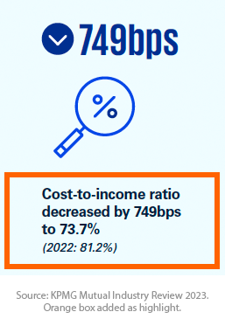
KPMG found a ‘significant improvement’ in the average cost-to-income ratio for mutuals, which dropped to an average of 73.7%. They noted this was still high when compared to the majors who had an average ratio of 51.4%.
In their analysis, KPMG observed that mutuals will try bridge this gap through organizational simplification, investment in productivity-enhancing technology and the use of commodity (or utility) services like shared payment services.
This mirrors our experience where mutuals are interested in digital solutions that can help simplify systems, particularly integrations, or that might be offered as a shared service to multiple mutuals.
The survey also called out the two significant mergers from 2023: Newcastle Greater Mutual Group and Heritage and People’s Choice. KPMG's analysis showed that inorganic growth options (strategic alliances, joint ventures, and mergers) will continue to be important ways for mutuals to access the benefits of scale.
This is consistent with our experience with mutuals who are looking for digital solutions that help them with integrations and also deliver a consolidated customer experience.

Industry-Wide Challenges
KPMG called out multiple sector-wide challenges facing mutuals including cyber incidents, risk and regulation, data protection, new competition, and access to talent.
The challenge of "Investing for the future through digitisation and modernisation" is of particular interest and worthy of additional exploration.

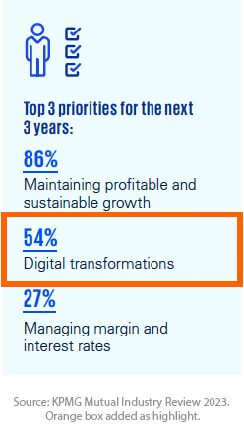
Digital Transformation
With these challenges in mind, it is unsurprising to see that Digital Transformation was the second highest priority for mutuals, chosen by 54% of executives.
While KPMG does not go into detail on what ‘Digital Transformation entails’, our experience suggests some areas of focus:
- Addressing the limitations of existing core banking and customer experience solutions (commonly provided by, and tightly entangled with, core banking) which often result in out-of-date digital banking experience.
- The need for a road map out of 'legacy system entanglements'. This is made urgent by concerns about the responsiveness and long-term viability of some core banking platforms. Mutual’s that we have spoken to have said they need to have a 'plan b' to decouple their systems to give them greater flexibility, reduce vendor lock-in risk, and deliver a better digital experience.
- Continuing to replace monolithic and proprietary systems with modern, cloud-native, microservice based, loosely coupled systems that leverage commonly used 'commodity' technology.

Customer experience and technological innovation
These digital transformation areas of focus match closely to the top strategies to improve customer experience found by KPMG.
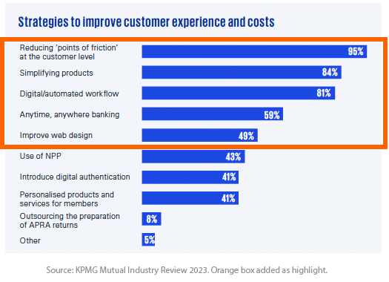
Four of the top five are related to digital channels:
- Reducing ‘points of friction’ at the customer level (95%)
- Digital/automated workflow (81%)
- Anytime, anywhere banking (59%)
- Improve web design (49%)
Unfortunately, it can be hard to be innovative and deliver these improvements if you are restricted by legacy systems or expensive software that no longer fits your needs. The following quote, from page 27 of the KPMG Review, sums it up well [emphasis added]:
[..], there’s a growing expectation for more innovative products and digital services, even amongst the mature customer segments that often are highly represented in mutual banks. Many mutual banks are still using legacy core banking and loan origination platforms, as well as operational and regulatory reporting systems, which may not be easily updated to incorporate customer and regulator expectations.
Adding to this is the fact that many mutuals might want to differentiate by creating new digital experiences & apps from scratch, but don't have the in-house skills, budget, or appetite for risk & compliance efforts.
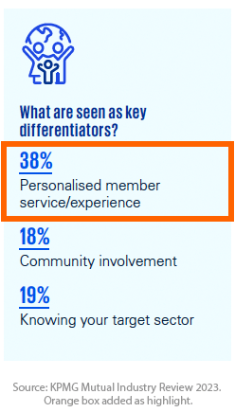
This desire aligns with the fact that KPMG found that ‘Personalised member service / experience’ was the top source of differentiation for mutuals, yet ‘Innovation’ was the second highest challenge, only slightly below ‘Data Integrity’.
With this in mind, we suggest that mutuals should look for digital offerings that can help deliver a modern customer experience to reduce friction points, while still by letting them keep and connect to existing systems through an abstraction layer.
Solutions that are mostly pre-built will also help reducing the burden on the limited IT budgets and allows mutuals to invest strategically in features that differentiate or help them 'meet their purpose', as discussed on the next page.

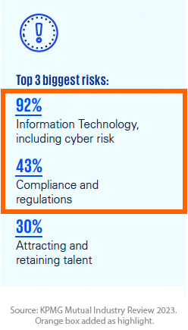
Cyber & Compliance Risks
Before returning to the topic of 'meeting their purpose', it’s worth noting the Top 3 risks identified by KPMG:
- IT, including cyber risk (92%)
- Compliance & regulation (43%)
- Attracting & retaining talent (30%)
Looking at the first two risks to start:
- Security – Look for a solution that has been built, from the ground up, with modern security practices so you can be confident it will pass the most demanding security audit and keep your customers & members as safe as possible.
- Compliance & Regulation – Look for solutions that align with multiple standards - including CPS 230, 234 & 235 from APRA (Australian Prudential Regulation Authority), PCI DSS & PII from the OAIC (Officer of Australian Information Commissioner), ISO 27001 and SOC 2. Solutions that align to these standards can help with your controls across things like Resilience Risks, Security and Data Risks, Technical Risks (Architecture) and Application Deployment Risks.
The next section looks at the third risk of attracting and retaining talent.

Meeting Your Commitment to the Community
On page 14 of the report, KPMG wrote:
Mutuals maintain powerful bonds with their members and the communities that they support, which continues to be a strength of the sector.
How does this bond and commitment to community relate to digital channels and customer experience?
Firstly, look for a solution that provides the core foundational elements of a digital banking customer experience (the standard features like viewing transaction lists or making payments, that you must have but don’t give you any real competitive advantage). Since you don’t need to rebuild these features (or recreate the wheel) it means that you can save your money and development efforts for new or unique features that help you supporting your members and the community. For example, you might:
- Offer a way for people to support local businesses or donate to local charities.
- Integrate with a new fintech or other financial service offering, such as the digital bank guarantee service that Avenue Bank is releasing.
Secondly, look at how any solution is delivered. Many tech vendors just sell a product and walk away. Look for a partner who delivers the products they build and has an approach where they work alongside your staff to scale and grow their capacity:
- Find a partner with a truly collaborative way of working. They should be locally based and expect to become part of your team for the project duration and beyond.
- Look for a partner who will also uplift and mentor your staff. By focussing on knowledge sharing, they will enable your staff to be self-sufficient during and after a successful delivery.

Simply put, a partner who keeps it local and helps empower your teams is more aligned to the mission and purpose of a community owned bank – to support the local community.
More importantly, by upskilling your team, they will help address the risk of attracting and retaining talent. Your staff are learning new skills with popular modern technology as well as innovative product-led customer-centric approaches.

Doing It All with Limited IT Budgets
KPMG found that tech spend has again increased, reaching 11.1% of total costs in 2023.
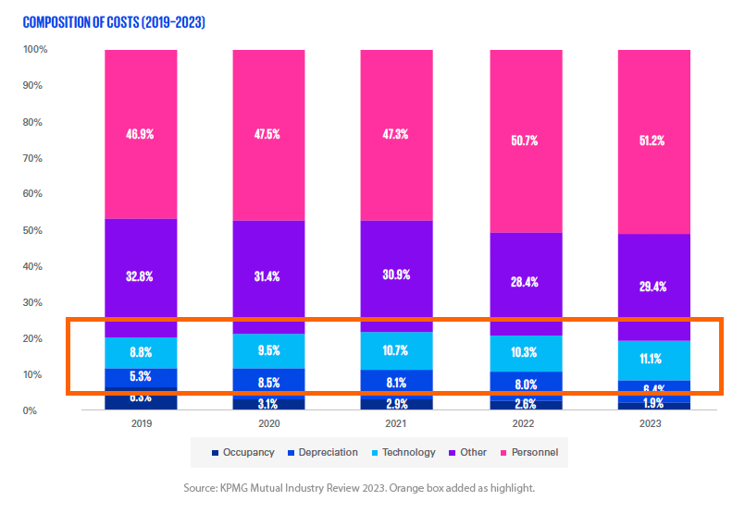
Even with these increases, we know that it's getting harder and harder to deliver innovative solutions that address these challenges within the budget available. An ideal solution may be to develop more shared services, but this can take time and would require the sector to work together in a way that hasn’t been seen in some time.
In the meantime, look for a solution that provides foundational elements of digital banking in a highly cost-effective way and is also designed to be part of a larger ecosystem. The result is that you can continue to leverage your existing technology investment without compromising the customer experience.

Introducing Ark

Ark, from Digizoo, is a set of pre-built modules that accelerates delivery of unique, usable & beautiful cross-platform banking apps and websites. Ark offers a sample app plus integrations, data models, and other capabilities needed in a highly regulated industry.
Ark not only tackles security and compliance risks but also contributes to talent retention by fostering collaboration and upskilling local teams. Its community-centric approach aligns with the ethos of community-owned banks.
As technology spending becomes more stretched, Ark stands out as a cost-effective solution, offering foundational elements of digital banking so you can focus on the features that help you meet your purpose.
Ark also helps your leverage your existing technology investments through the Ark-Core abstraction layer, that makes it easier to integrate with your chosen partners and vendors. This is seen in the component diagram on the next page.
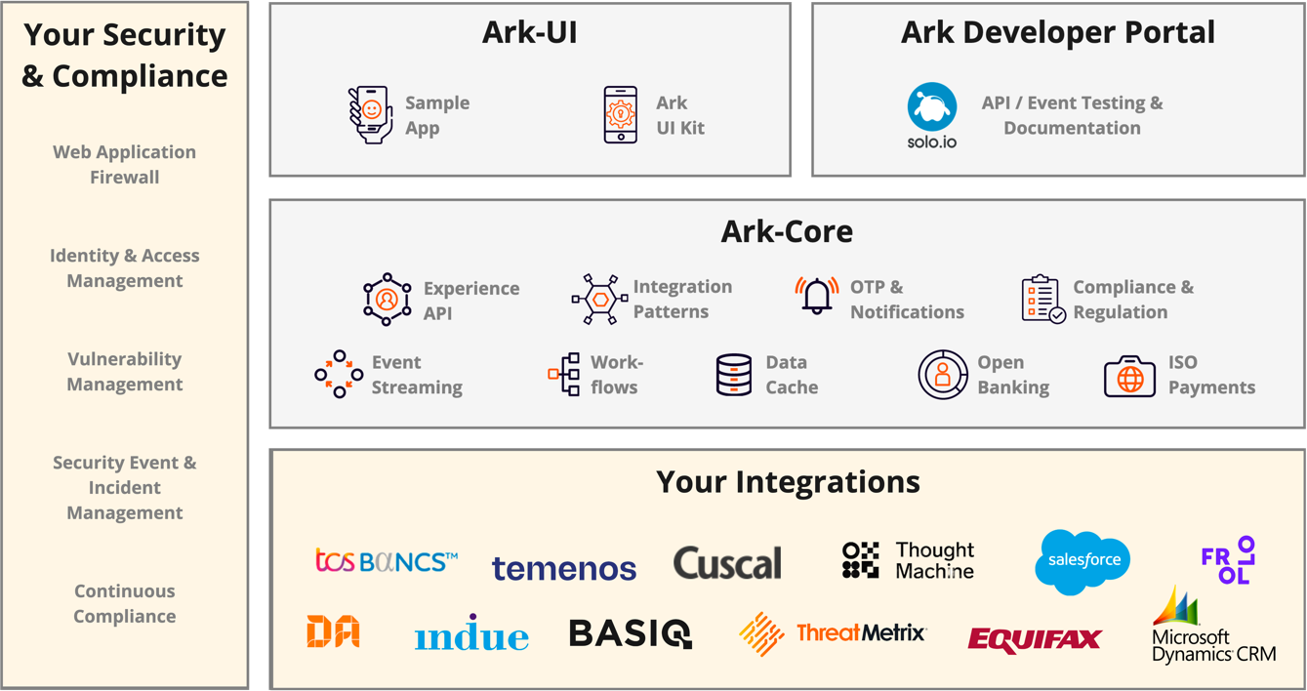

Conclusion
The KPMG Mutual Industry Review 2023 identifies key challenges faced by Australian customer owned banks & mutuals. The review underscores the sector's focus on digital transformation, emphasizing the need to address legacy system limitations. Ark helps with this, promoting modernization and differentiation through unique member services, all delivered by Digizoo in a collaborative way that uplifts your staff.
Find out more at Digizoo.com.au and OneArk.com.au

Sample LinkedIn Article: Why do 48% of tech companies fail to communicate respectfully to recruitment applicants?

October 11, 2023

In the aftermath of the 400,000+ tech industry redundancies that occurred in 2022 and early 2023, I've heard many stories from friends and colleagues who have applied for a new role, only to be met with silence.
One good friend tracked 9 months of applications for over 100 roles, all with technology companies. Shockingly, nearly half (47%) of their applications were confirmed received, but then there was nothing but silence. No "thanks but no thanks" email. Nothing.
This isn't just an inconvenience; it's a sign of disrespect to candidates who invest time and energy into tailoring an application - each taking an hour or more.
In an era where automation and AI tools are abundant, particular for the tech companies I'm taking about here, there's no excuse for failing to send a simple thank you and acknowledgment that they are not proceeding with the application.
Recruitment teams have access to a wealth of technology that can streamline their processes and ensure that no candidate is left in the dark. Every single Talent Acquisition software product should let you send emails when events happen, like when a candidate's application is marked as not progressing. I've demonstrated these tools when I worked at SumTotal Systems, LLC, now part of Cornerstone OnDemand, and know that we had that functionality.
That’s why statements like “due to the high number of responses, we will only respond to candidates that have been shortlisted” are just a cop-out.
So why don't recruiters use these tools properly? I wish I knew.
Automated emails are a simple yet effective tool that can be employed to let candidates know where they stand. This not only demonstrates professionalism but could be used to foster a positive candidate experience, leaving individuals with a favourable impression of the company, even if they weren't the perfect fit for a specific role.
These same tools can update candidates on the status of their application - for instance that the process has been delayed or that role might have been put on hold - so that candidates aren't left wondering.
Consider the broader impact of this lack of communication.
Candidates who feel undervalued or dismissed are likely to share their experiences with their professional network (like I’m doing here). This could potentially tarnish the reputation of the company, affecting its ability to attract top talent in the future.
Should I ask my friend to provide the list of tech companies who didn't bother to respond, in order to name and shame them here?
Recruiters would do well to remember that every applicant is a potential brand ambassador. Treating candidates with respect, transparency, and courtesy is not just professional, it's an important reflection of a company's values and its commitment to creating a positive workplace culture.
In past, when I was recruiting for my team, I would send a personal email to every person I had interviewed to say thank you and wish them the best. I'm still in touch with many of them today, because no-one knows what the future might bring.
So, to all my fellow professionals out there who have been left wondering about the status of their applications, know that you are not alone.
And, to the talent acquisition professionals who read this, can you please make the effort to elevate your industry by putting respectful communication back at the forefront of your practices?

Sample LinkedIn Article: MyBupa app & How NOT to roll out a new digital service.
September 22, 2023

Digital experience is the top priority
I want to discuss how NOT to roll out a major update to your app or authentication process, using the example kindly provided to me by Bupa.
Bupa is multinational health insurance and healthcare company with over 43 million customers worldwide. Although, as of today, they have one less customer - me.
If you don't want to read the full tale, scroll to the bottom for the Too Long, Didn't Read (TL;DR) summary of what they should have done differently.
Delivering a good digital experience to your customers must be your top priority, whether you are an insurer, bank, transport & logistics company or retailer. If you don't, people will leave, just like I did today.

Important changes to how you sign in
This tale started on 1st of Sept, and ended today, just over 3 weeks later when I gave up and moved to a new health insurance provider. I switched insurance providers, because Bupa's new digital ID release prevented me from using both the app and website to lodge claims. This is the primary use case for a health care insurance customer via their digital channels.
On August 29th, Bupa rolled out an updated mobile app and new authentication system called Bupa Digital Identity, that forces you to re-register.

If you hunt around, you can find out why they are doing this
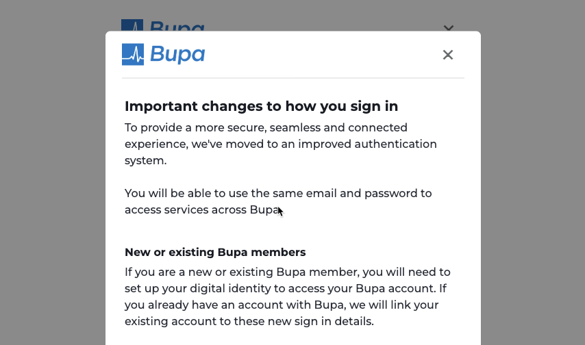
Despite the fact this was important, I had no idea this was coming, because Bupa didn't send me any email notifications prior to the rollout. Mistake #1.
Lesson: Tell your customers that you are making the change before you do it.
At about 9:15am on Friday Sep 1st, I tried to get in to my Bupa app to make a claim and saw, for the first time, that I had to re-register with a new account and set up a new Bupa Digital ID.
This should not be too hard, right? I'm a digital native and I'll only need to do it once. I was wrong.

Re-registration was unnecessarily painful
To start, the re-registration form asked for my details. Didn't they already have this info in the existing app? Why couldn't I login and use the data stored there? Not content with asking me to enter data manually, they even asked for my mobile phone number twice. TWICE for the same piece of data. Mistake #2.
Lesson: Don't ask for data you already have. If you have to ask for information, only do it once.
After entering my phone number a second time, they had to validate it. But when the one time password (OTP) came in as a SMS on my phone, only the first number was correctly entered using the iOS code auto-entry feature. I also tried validating using the web UI, but that would not let me copy and paste the one time code into the validation field. Bupa's user acceptance testing should have picked up that supportive technologies in the operating system did not work correctly with the app, and that you couldn't paste OTP codes on the web. Mistake #3.
Lesson: Don't break standard system functionality especially assistive technology.
When I tried logging in today, I see they have fixed the iOS bug (as seen in the screen below), but it happened enough times to REALLY annoy me.
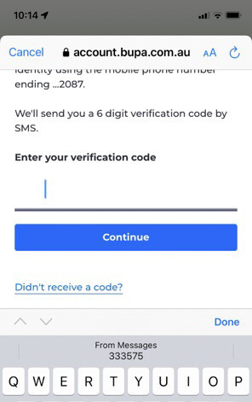
Entering one time code on iOS
Come to think of it, why does Bupa insist on doing 2 Factor Authentication (2FA) by SMS, which is not a secure approach. Mistake #4.
Lesson: Give users the option to use a more secure authentication app like the ones from Microsoft or Google, rather than only relying on SMS
More importantly, why do I need to re-register and set up a new account? Why did Bupa have to make me do all this in the first place? Mistake #5.
Lesson: Either automatically migrate customers to the new account & digital ID or make seamless for them to do it from within the existing app without requiring the customer to re-enter details.
To add insult to injury, even after setting up the new digital ID and logging in the first time, the new app keeps repeatedly asking if I had already set up the new Bupa Digital Identity. And it doesn't just ask once.. It asks if I have an digital ID and then a modal window asks again, just to be sure. This is seen below.
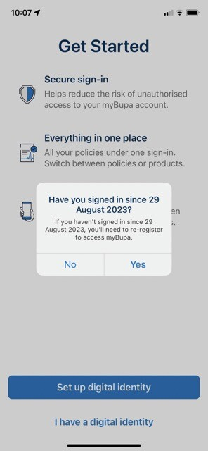
And it does this EVERY time I try to login. Mistake #6.
Lesson: Don't ask the same questions every time. Ask me once, then remember.
In any case, by 9:36am, I had re-registered my account and set up my new Bupa Digital ID. Now I can login. We're done right?

I'm in. But then it gets worse. WAY WORSE.
After I was finally able to login I saw a "No active policies found" message that told me Bupa couldn't find any policies to link to my account.

Computer says no. Call us. If you dare.
All I could do was use the Contact Us button, which took me to this screen.
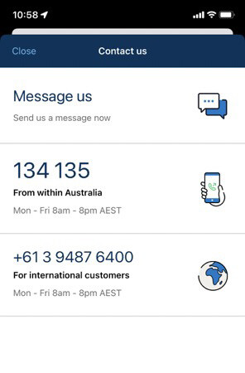
Contact us options
I sent a message and also called them. Thankfully it was a Friday, because if it was Saturday, then no-one would be there. Mistake #7.
Lesson: If you are rolling out a major change to app, login or other functions, you need weekend support.
The call took 36 minutes in total, with a wait time of about 15 minutes. The messaging took even longer to respond to, and by the time 'Harry' had got back to me in the messaging service, I was already done with the call, as seen below.
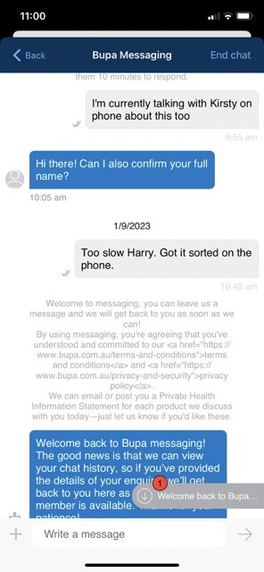
However, both support avenues too far too long to get an initial human response. Mistake #8.
Lesson: If you are rolling out a major change to app, login or other functions, you need to massively increase your support staff.
Now, I'll talk about the pain of using the in-app messaging below, but first, lets cover the phone conversation I had with Kirsten. She confirmed that my Bupa policy was active, but couldn't determine why it wasn't showing up when I logged in to website or app.
it took about 10 minutes of holding, but she finally came back with the theory that perhaps the policy might not be connected to new digital ID. Unfortunately she couldn't fix this. She had to escalate it to 'the IT team'. She did this and assured me it would be fixed. But I got no email, no case number, so resolution time. Mistakes #10 and #11.
Lesson: If you are rolling out a major change to app, login or other functions, you need to have real time data flowing to the development team so they can see if there are major issues that require with rapid resolution or release rollback.
Lesson: If a case is created, especially one that requires escalation to another team, your help desk system should send automatic emails when the case is created or updated.

It wasn't fixed. Ever
Despite Kristen's assurances, it never got fixed.
I tried logging into the app again on September 9, 11, 16, 18, 19 and today, 22 Sep. I saw the same "No active policies found" notice, every single time.
I sent multiple messages using the in-app messaging service, which is so terrible that I want to address it separately, below.
On Sept 16, I called again. After navigating the labyrinth of call options, I got the lovely message that they were closed for the weekend. See Mistake #8 again.
And, while there is a link to a callback service on their website - so you don't have to wait in the line or you can get them to call you back on a working day - they don't offer the same service on the phone. Mistake #12.
Lesson: Have a consistent omni-channel experience with a callback service available on all touch points.
On Sept 18, I called them again. Total call duration was 33min, with about 2/3 of that spent on hold. I finally got through went to a person, whose name I missed. That person put me through to a 'specialist team' where I spoke with Marie. Marie confirmed that my case was raised on 1/9, but couldn't help. She said my call had to go to another specialist 'Customer Care' team and then passed me to Jodie, who was actually in the Memberships team. Jodie said that the turn around time is 10 to 12 business days, and that 12 business days was tomorrow, Sept 19th. I would have to wait another day. Mistake #12.
Lesson: Stop passing around customers like a deflated football. Give support reps everything they need to fix the problem at the first touch point.
Note that I did try logging in on Sept 19th and 22nd, which is today. It was not fixed.

Phone calls were bad. Messaging was worse
So lets look at the joy of trying to message Bupa through the app.
Now, to be fair, they do note that this is NOT an instant messaging service. Its an asynchronous service that can take some time to reply to. Any, by 'some time', they really mean anywhere from 15 min to hours.
But, still, this messaging service is unbelievably frustrating and borderline useless. Here are a few screenshots to put the issues in context. Note the last image, which
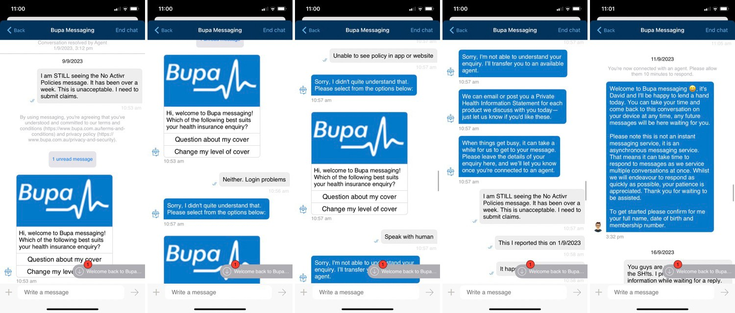
Some of the issues with messaging:
- The chatbot is STUPID. It has a very limited number of prompts and could not handle any of the queries that I asked it.
- The chatbot asks the same question three times before it puts you through to a person, even after you ask for a human, a support rep etc.
- The chatbot reappears if you are not active in the chat for a while. Since it takes Bupa so long to reply, this is nearly inevitable. In other words, if you ever manage to get through to a person, and give them the information they need to respond, by the time they do respond, you've moved on. Then when you finally go back to the app, you have to start again!
- One of the reasons you move on and don't come back in time, is because the messaging service does NOT trigger a phone notification when a response is received (no badging, no alerts etc). Nor do they send you an email. So you basically don't know someone has responded until you go back to the app. And, yes, I checked that notifications were enabled.
- You can't access the in-app messagin, unless you are logged in. This means you have to go through the painful login process described above, before you can see if someone responded to you.
- Despite the fact that you can only see messaging on the app once you are logged in, it will repeatedly, automatically, ask you for your full name, dob and address. As if this somehow makes it more secure. Despite providing this while waiting to be connected, I was asked for it again when the support rep joined the chat.
One final messaging screen shot from today.
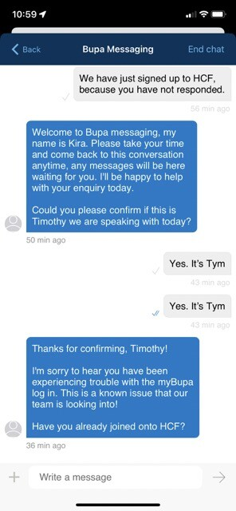
Some things to note from this:
- It was faster to sign up to a new provider (HCF) over the phone than it was for someone at Bupa to respond.
- Kira asked me if this was Timothy. Didn't I just use their new and more secure Bupa Digital Identity to prove that? Also, I've told them multiple times that my preferred name is "Tym". They don't use it.
- This login problem is a 'known issue', yet there are no notifications or messages about it anywhere on the site or in the app. A search for Bupa "No active policies found" brings back zero exact matches.
There are lots of lessons from the messaging debacle, but to prevent repetition, I'll add them to the closing TL;DR

TL;DR & Conclusion
Bupa lost a customer today because they made a mess of the rollout of a new authentication service that was supposed to make my life better.
To prevent that happening to you, here are some lessons to take from this:
Planning
- Tell your customers that you are making the change before you do it. Don't just post a notice on the website.
- Either automatically migrate customers to the new account & digital ID or make seamless for them to do it from within the existing app without requiring the customer to re-enter details.
- If there are know issues that will prevent a migration, either pause the process or be sure that customers and staff are well informed. Make sure the information comes up when someone searches for the error message.
Support & Staffing
- If you are rolling out a major change to app, login or other functions, you need to massively increase your support staff, provide weekend support and have real time data flowing to the development team so they can see if there are major issues that require with rapid resolution or release rollback.
- Stop passing around customers like a deflated football. Give support reps everything they need to fix the problem at the first touch point.
- If a case is created, especially one that requires escalation to another team, your help desk system should send automatic emails when the case is created or updated.
Customer Experience
- Have a consistent omni-channel experience with a callback service available on all touch points
- Use a customer's preferred name on all touch points
General Digital Experience
- Don't break standard system functionality especially assistive technology.
- Don't ask for data you already have. If you have to ask for information, only do it once.
- Don't ask the same questions every time. Ask me once, then remember.
Messaging and Chatbot Experience
- Use a chatbot that can respond to a wide range of enquiries and put you though to a person when you ask.
- Ensure that messaging responses are timely and trigger a notification so the customer knows you've replied
- Don't force a customer to login to chat. If a customer does login to chat, then rely on your authentication and don't ask them to validate their ID again.
Security
- Give users the option to use a more secure authentication app like the ones from Microsoft or Google, rather than only relying on SMS

Sample LinkedIn Article: The new Australian Positive Duty and what it means to you - Part 3: The importance of reporting and monitoring
September 20, 2023

Introduction
Welcome to Part 3 of this three part series. Part 1 explored the background of the Respect@Work legislation, its implications for businesses, and our progress so far. Part 2 looked deeper at the seven standards and the actions every business needs to take.
In this final part I’ll dive deeper into the importance of reporting and provide useful considerations when selecting technology to help you comply with the positive duty.
Disclaimer: While I am providing consulting services to RepSafe Pty Ltd, this article was written in my private capacity and does not represent the views or opinions of that, or any other, company. This article should not be taken as legal or other professional advice.

The Good Practice Reporting Framework
While policies and training are crucial, an essential part of an effective positive duty implementation is a well-designed reporting framework.
It's important to note that traditional reporting channels such as relying on staff to raise issues with HR or using standard web forms or phone hotlines are not adequate. The AHRC notes that these conventional approaches are ineffective, distrusted by workers, and even damaging to victims as they often limit the reporting channels, require an excessive level of information and even prevent earlier, more informal interventions.
A good practice reporting framework addresses these limitations and offers a more inclusive and supportive environment for reporting incidents.
The Good Reporting Framework page on the Respect@Work site provides practical guidance on establishing a good practice framework based on nine key principles:
- Accessibility, Clarity, and Simplicity: Reporting processes and information should be well-documented and easy to understand. Responsibilities and actions should be clearly defined, using plain and neutral language.
- Timeliness: The framework should prioritise prompt and ethical resolution, avoiding slow, dismissive, or discouraging approaches towards victims.
- Transparency: Information about the reporting process, including decision-making procedures, should be easily accessible and understandable.
- Reporting Avenues: Various internal channels, both formal and informal, should be available. External channels should also be identified for workers to make reports of sexual harassment.
- Resolution Pathways: Multiple options for resolution should be provided, with an emphasis on early intervention and giving the victim/complainant a voice. Acknowledgment that an investigation may not always be the best course of action.
- Outcomes and Consequences: The potential consequences of substantiated sexual harassment allegations should be clearly outlined.
- People-Centred: Prioritising the well-being and safety of victims and other impacted individuals. Support should be readily available and integrated into the processes.
- Prohibition and Victimisation: Victimisation should be strictly prohibited, and consequences should be applied if it occurs.
- Confidentiality: Clear boundaries of confidentiality should be established while a matter is being resolved. Victims should not be prevented from discussing their experiences once the matter is concluded.
Additionally, any report, regardless of its formality or outcome, should feed back into the risk management process.

Utilising Digital Platforms and Technology
Digital platforms and technology play a vital role in enhancing the effectiveness of reporting frameworks. These innovative tools provide greater flexibility and convenience for reporting incidents, including anonymous reporting options. They allow individuals to submit reports securely and confidentially, reducing fears of victimisation or traumatisation that may arise during an investigation process.
Digital reporting platforms also facilitate the collection and analysis of incident data, offering organisations valuable insights to address systemic issues and develop targeted solutions.

Tips for Selecting Technology
As organisations seek technology solutions to support compliance with the positive duty, several factors come into play:
- Purpose-Built Solutions: Avoid the temptation to rely on generic tools like Google Forms or Survey Monkey. They lack the necessary security and functionality. Instead, opt for a Software as a Service (SaaS) solution designed explicitly for this purpose.
- Customization: Ensure that the chosen solution can be customised to meet your specific needs. This includes adding content related to your company's policies, adjusting reporting questions, or modifying dashboards.
- Data Security: Prioritise data security. Look for a solution that uses strong encryption in transit and at rest. This extra layer of security ensures that sensitive information remains protected.
- Accessibility & Usability: Verify that the chosen solution is accessible and user-friendly on both desktop and mobile devices, ensuring that all employees can easily engage with it.
- Confidentiality and Anonymity: Emphasise the importance of confidentiality, anonymity, and the protection of privacy. Look for a reporting solution that supports both formal (named) and informal (anonymous) reporting avenues.
- Integration: While integration is often sought after in IT solutions, in this case, it's important to maintain a standalone system to ensure true anonymity and privacy. Any integration should focus on verifying the person's identity as an employee or stakeholder without revealing personal information in the reporting process.

Repsafe: An Australian-made Reporting Tool
A good example of a digital reporting tool is Repsafe, a safe and anonymous reporting tool designed specifically for Australian organisations. Repsafe enables employees and stakeholders to report incidents securely and confidentially, whether identified or anonymous. It offers customisable questions and reports, along with a management workflow system to ensure timely and appropriate action. The platform also provides de-identified and aggregated data tailored for boards, offering a comprehensive picture of incidents within the organisation.
You can see a 5:30 demo below.

Wrap Up
The journey toward cultural change and compliance with the positive duty is still in its early stages. It's likely that more stories of workplace misconduct will come to light in the coming years.
However, the introduction of the new Positive Duty in Australia signifies a significant milestone in the fight against sexual harassment and discrimination in the workplace. It serves as a crucial wake-up call for all of us, not just HR professionals..
All employers and people conducting a business now have a legal obligation to proactively prevent unlawful conduct. This requires action across all the seven standards which includes implementing comprehensive policies, training programs, and, importantly, a good practice reporting framework.
By adopting innovative digital tools like Repsafe, Australian organisations can continue to create safer, more inclusive work environments, where incidents of harassment and discrimination are swiftly addressed, and the voices of victims are heard and respected.

Useful Links
Here are those useful links again.
- Respect@Work: Sexual Harassment National Inquiry Report (2020) | Australian Human Rights Commission - The main page of the Respect@Work report
- The Positive Duty under the Sex Discrimination Act | Australian Human Rights Commission - has useful factsheets and guides
- For organisations | Respect@Work - the organisation page on the Respect@Work site
- New positive duty on employers to prevent workplace sexual harassment, sex discrimination and victimisation | Respect@Work - the positive duty page on the Respect@Work site
- Reporting | Respect@Work - the reporting page on the Respect@Work site.
- Respect@Work Act 2022: Consequences for non-compliance - consequences for non-compliance analysis from SafeTrac, part of their Respect@Work 2022 content
- RepSafe - homepage for the Australian made and hosted incident reporting and tracking tool.

Sample LinkedIn Article: Zen and the APIs of Motorcycle Registration

January 24, 2021

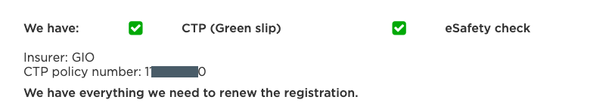
- Government organisations like TfNSW need to expose a secure interface - commonly call an Application Programmer Interface or API - for their partners to connect to. These interfaces will have changed substantially since the first system was put up in 1999, as today's developers expect a modern API based on an approach known as REST. TfNSW's external REST APIs need to be connected to their internal systems in a stable and scalable way - so a change made in a service centre, or on the website, is immediately available through the API.
- Every Authorised Inspection Station (AIS) - such as my local motorcycle service centre - needs to be able to connect to these APIs and securely update the status of my bike safety check. This could also be done manually through the AIS Online system, but it's much easier if the software used to manage the repair workshop can connect directly to the APIs and automatically submit the update when the technician finishes inspecting my bike. This means that the workshop management software vendor has to do things like access the API documentation made available by TfNSW and even register for an API key to test that their software uses the APIs correctly.
- Similarly, GIO's insurance quoting systems need to be able to connect to the TfNSW APIs to securely access and update the data about my bike, license or address in real-time. The updated data that flows into the quoting system then needs to be correctly shared with all their other applications, such as a billing or claims management system.
- Finally, in order to deliver a world-class, one-stop-shop, Service NSW needs to connect to the many different systems used by NSW gov agencies. This includes that APIs exposed by TfNSW along with those from other agencies such as NSW Police (for a firearm license) or the Department of Primary Industries (for a recreational fishing license).

Sample LinkedIn Article: Build Your Smart City with TIBCO
September 19, 2020
This article was originally published 16 Sept 2020 on the TIBCO Blog.

Smart Cities Are the Future
With the rise of COVID-19, many countries are realizing how a smart city framework could help ease the spread and control of the pandemic. For example, sensors to track contacts and monitor those under quarantine have helped keep the spread under control in places like South Korea.
So, if a connected, responsive, data-driven city can help improve people’s health and well being – why don’t we have this tech everywhere? The answer: it’s hard to do.

Why Are Smart Cities Hard?
First, you need to note that a smart city is a system of systems. For instance, you have assets (let’s say cars or temperature tracking cameras) and those assets need to be able to run updatable software to make them ‘smart’ and then connected to individual systems. All of these individual systems are incredibly complex systems to build and, to make a true smart city, the many individual systems also need to be interconnected, which makes it even harder.
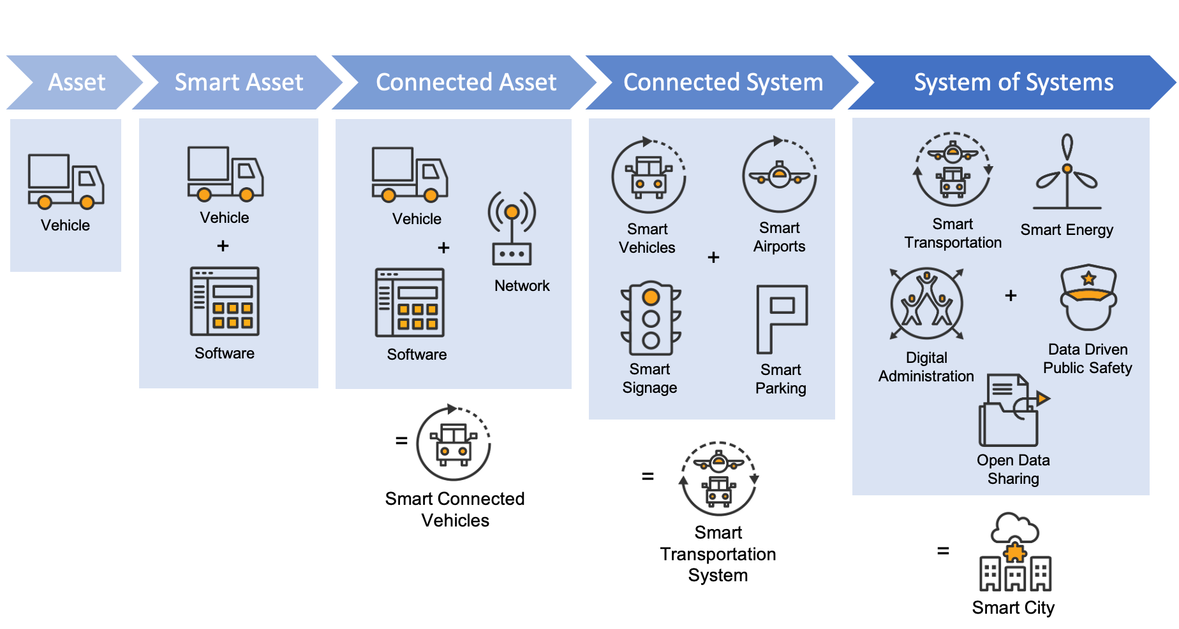
Plus, remember, there are lots of different applications of these interconnected systems: from economic development and civic engagement to sustainable urban planning or intelligent transportation. You might want to target data-driven public safety or focus on resilient energy and infrastructure. It can be challenging to address all these different use cases.
Thankfully, TIBCO has the capabilities to enable the smart cities of the future, with solutions that can:
- Seamlessly connect systems and application sources all the way out to the edge where data is collected on IoT devices.
- Unify disparate datasets, both static and real-time, so you have well-controlled access to trusted, well-governed data.
- Use that data to confidently predict outcomes with real-time data-driven machine learning and Artificial Intelligence (AI)I.
TIBCO provides all these capabilities and is already powering smart city components around the world. Let’s look at some examples in just one area: intelligent transportation.

Making Intelligent Transportation Possible
In the intelligent transportation realm, TIBCO is helping CargoSmart look at over 5500 vessels using visual analytics and data science capabilities to optimize their journeys to save fuel and manage arrival times. As a result, CargoSmart developed a vessel speed and route monitoring application that analyzes the vessel’s speed and distance against a complex variety of factors. The application has helped ocean carriers reduce fuel consumption by up to 3.5% over the past two years.
Another great example comes from an Australian Capital city that used TIBCO for a quick win pilot to track real-time car park occupancy and notifications as well as car park optimization and parking anomaly detection. These solutions are, more and more, being powered by data science, AI, and Machine Learning that is able to recognize moving objects – such as cars – and then use that to track traffic going into, or out of, different places such as car parks. Staff from the TIBCO office in Sydney, Australia, recently demonstrated just how that might work using a public webcam looking out on the Sydney Harbour Bridge.
One last example is seen in how Aeroporti di Roma uses TIBCO to integrate and correlate all its information sources, in order to effectively analyze passenger flow & behaviour, improve customer experience, and support operational awareness to better mitigate problems. In 2018 and 2019 Rome Airport won EUROPE Best Airport Award in the ‘over 25 million passengers’ category.

Need More?
To learn more about how TIBCO is enabling cities of the future and how these capabilities can help your business, please download my How to Build a Smart City & Smart Nation whitepaper or watch my “How to Build a Smart City in 40 Minutes (or Less)” on-demand webinar.

Sample LinkedIn Article: Defeating Deep Fakes
June 1, 2020

Deep Fakes will get us in Deep Sh!t
If you are not worried about the impact of deep fakes (or deepfakes) on politics, business and human society, then I'd suggest you don't really understand what they are. So, let's start with a definition from Wikipedia:
Deepfakes are synthetic media in which a person in an existing image or video is replaced with someone else's likeness. [They] leverage powerful techniques from machine learning and artificial intelligence to manipulate or generate visual and audio content with a high potential to deceive.
To understand the social and political impact, a good place to start is a recent (May 2020) analysis on the Forbes website by Rob Toews titled "Deepfakes Are Going To Wreak Havoc On Society. We Are Not Prepared". In short:
- Experts predict that deepfakes will be indistinguishable from real images before long.
- Deepfakes have begun to spread to the political sphere, because they will make it "increasingly difficult for the public to distinguish between what is real and what is fake, a situation that political actors will inevitably exploit—with potentially devastating consequences".
The Forbes article also quotes a Jan 2020 report from the The Brookings Institution which identifies some of the political and social dangers from deepfakes as follows: "distorting democratic discourse; manipulating elections; eroding trust in institutions; weakening journalism; exacerbating social divisions; undermining public safety; and inflicting hard-to-repair damage on the reputation of prominent individuals, including elected officials and candidates for office."
The Nov 2019 "Fighting deepfakes when detection fails" article by Alex Engler, also from the Brookings Institute, describes the three effects of deepfakes within politics and the social sphere:
- Disinformation: People are more likely to have a visceral reaction to disinformation in the form of fake image, audio, and video content, which enables the altered media to spread more quickly than purely textual fake information.
- Exhaustion of critical thinking: It will take more effort for individuals to ascertain whether information is true, especially when it does not come from trusted actors. Uncertainty around content veracity might also dissuade an individual from sharing accurate content, reducing the distribution of accurate information.
- The liar’s dividend: The existence of fully synthetic content offers an avenue for actors to deflect accusations of impropriety based on recordings and video, by claiming the source material has been faked.
The end result will be an increase in truth decay, as coined by Jennifer Kavanagh and Michael D. Rich in a RAND Corporation paper from 2018 titled “Truth Decay: A Threat to Policymaking and Democracy”
Things are no better in the world of finance & business. ComputerWeekly reports that 77% of cyber security decision makers "are worried about the potential for deepfake technology to be used fraudulently – with online payments and personal banking services thought to be most at risk – but barely a quarter (28%) have taken any action against them".
Indeed, in March 2019, fraudsters used an audio deepfake to steal €220,000 from the CEO of a U.K.-based energy firm. The thieves used AI to impersonate the voice of the firm's parent company's chief executive, asking the CEO to send the funds to a Hungarian supplier within an hour. While this was the first known cybercrime in which criminals clearly drew on AI, it won't be the last.

Detecting Deepfakes
Currently, there is a lot of work being done by Google, Facebook and others on how to identify and stop deepfakes. Most of these approaches are focussed on training other AI / Machine Learning systems to detect deepfakes, since humans are so easy to fool.
Unfortunately, this approach seems doomed to failure.
Firstly, as noted by Drew Harwell in a June 2019 article in The Washington Post, the capacity to generate deepfakes is proceeding much faster than the ability to detect them.
Worse, the latest development in detecting deepfakes are quickly used to train the models used to create better deepfakes, as pointed out in the Nov 2019 article by the Brookings Institute. So, the various ways to detect deepfakes - like distortion in facial features, inconsistencies across images within a video (especially concerning lighting), incongruities between the speech and mouth movements of the subject, and even learning to note the absence of biometric patterns specific to world leaders - will all fail sooner or later.
For example, the Washington Post article by Harwell tells the story of Siwei Lyu, the director of a computer-vision lab at the State University of New York at Albany, who helped pioneer research in 2019 that found many deepfakes had a telltale clue: a lack of blinking. Unfortunately, two weeks later, "Lyu received an email from a deepfake creator who said they had solved the problem in their latest fakes".
Finally, even if reliable modes of detecting deepfakes exist, they will almost invariable trail behind the generation of new fakes, allowing false representations to dominate the conversation.

I'm Looking at You, Lou
It was Lou Reed who said, or rather sang, in Last Great American Whale:
Don't believe half of what you see and none of what you hear
The first thing we need to do is change this, so that the default position becomes:
Don't believe any of what you see and none of what you hear (on a screen)
Then, once we have the right level of critical thinking and incredulity established - where we assume everything is fake until proven otherwise - we need a way to objectively and absolutely prove that a video or audio file is a genuine record of what happened in reality.
There are numerous suggestions on how to do this, such as reverse video search or blockchain-based verification / authentication system that would fingerprint footage right as it’s captured. As the Washington Post article notes, "this could help make fakes easier to spot, but would require agreement from makers of smartphones, cameras and websites — a far-off proposal that could take years". In addition, while blockchain-based verification can prove that a video hasn't been altered, it doesn't prove that the video was real in the first place. So, while that might be part of the solution, its not enough.
Instead, I want to make a suggestion based on the work of my favourite sci-fi author, Iain M. Banks ...

A lesson from the Culture
Science fiction can not only predict future problems, but it can also give clues on what a solution might look like. In this case, the problem of deepfakes reminded me of a situation in "The Player of Games" a book written in 1988 by the sadly departed, Iain M. Banks.
This book involves characters from the Culture, a utopian, post-scarcity space society of humanoids, aliens, and advanced artificial intelligences (drones and Minds). Early in the novel, the main character, Jernau Gurgeh, took advantage of an offer by a former Special Circumstances (SC) drone named Mawhrin-Skel to get an an unfair advantage over another game player named Olz Hap. The drone then uses this to blackmail Jernau. I've reproduced the relevant section below, with key parts marked in bold:
Mawhrin-Skel floated into his field of view. 'Listen to me, Jernau Gurgeh.' Some cold drops of rain started to patter into the grass and on to his face. 'Listen to me…. You shall help me. I have our entire conversation, your every word and gesture from this morning, recorded. If you don't help me, I'll release that recording. Everyone will know you cheated in the game against Olz Hap.' The machine paused. 'Do you understand, Jernau Gurgeh? Have I made myself clear? Do you realise what I am saying? There is a name - an old name - for what I am doing, in case you haven't already guessed. It is called blackmail.'
The machine was mad. Anybody could make up anything they wanted; sound, moving pictures, smell, touch… there were machines that did just that. You could order them from a store and effectively paint whatever pictures - still or moving - you wanted, and with sufficient time and patience you could make it look as realistic as the real thing, recorded with an ordinary camera. You could simply make up any film sequence you wanted.
Some people used such machines just for fun or revenge, making up stories where appalling or just funny things happened to their enemies or their friends. Where nothing could be authenticated, blackmail became both pointless and impossible; in a society like the Culture, where next to nothing was forbidden, and both money and individual power had virtually ceased to exist, it was doubly irrelevant.
The machine really must be mad. Gurgeh wondered if it intended to kill him. He turned the idea over in his mind, trying to believe it could happen.
'I know what's going through your mind, Gurgeh,' the drone went on. 'You're thinking that I can't prove it; I could have made it up; nobody will believe me. Well, wrong. I had a real-time link with a friend of mine; an SC Mind sympathetic to my cause, who's always known I would have made a perfectly good operative and has worked on my appeal. What passed between us this morning is recorded in perfect detail in a Mind of unimpeachable moral credentials, and at a level of perceived fidelity unapproachable with the sort of facilities generally available.
'What I have on you could not have been falsified, Gurgeh. If you don't believe me, ask your friend Amalk-ney. It'll confirm all I say. It may be stupid, and ignorant too, but it ought to know where to find out the truth.'
So, within the Culture, where anything can be faked, the only way to prove something real is that it has been simultaneously witnessed by one or more entities who are trustworthy.
How can this help solve the problem of deepfakes in our society?

Real Time Validation by Trusted People
Just like in the Culture, the only way to ensure that something is 100% real is for multiple witnesses to simultaneously record the event, from multiple viewpoints. As more and more people record or stream their daily lives - on smart phones, dashboard cams, drones and more - this is not an impossible idea.
These recordings should ideally be encoded using block chain technology to validate the recording and ensure it can't be later changed.
Then using computer vision systems, AI tools can compare videos of the same event - even if they are taken from different angles - and reconstruct the scene with absolute certainty.
None of this is impossible. Indeed, this would use the sort of computer vision technology that the talented ANZ presales team at TIBCO have already started to experiment with. Plus, the TIBCO Labs team have recently released Project Dovetail, which provides a very useful blockchain framework that can be used for digital contracts and more.
Media organisations should do this first, and so establish the "unimpeachable moral credentials" that are so important for society to again agree on objective truth.
Finally, when these sorts of tools are available to anyone - not just reputable media organisations who invest in fact-checking - of then we perhaps we can leave behind the "post-truth" work stop the 'truth decay' that is starting to rot our society.

Sample LinkedIn Article: Five tips to get your continuous feedback approach right

August 31, 2017
- Documenting regular coaching. Too often managers think ‘a chat’ will help ease possible concerns or make an employee feel heard, but this is only true if they know their views are taken seriously. What you need is a system in place that enables informal conversations to be documented and actionable by focusing on areas of development that need improvement. You don’t want continuous feedback to become so ‘casual’ that it’s essentially meaningless.
- Linking performance process to career planning and learning. Managers should be constantly identifying employee skill and competency gaps to pinpoint career development opportunities and areas for improvement in their current role. Nothing is less motivating for an employee than constantly talking without a genuine plan to help them progress.
- Enabling pay-for-performance to build a merit-based culture. Programs that align employees’ compensation – merit increases, bonuses, long-term incentives – to their performance have proven to be very effective in driving actual performance. A single, centralised platform that natively connects all components for pay-for-performance is required because it facilitates cross-functional reporting and eliminates the technical challenge and cost of integrating and managing disparate systems.
- Creating an individualised path for development, rather than following a standardised hierarchy. When organisations empower individuals with the capability, support and freedom to create and pursue their own personalised paths for growth and connect them with the right tools and resources, that is when employee engagement and retention and business outcomes improve.
- Configuring, not customising, your performance management technology. Customisation is a development-centric exercise that extends an application beyond what it was designed to do, whereas configuration makes declarative changes to an application without jeopardising future upgrades. The benefits include lower total cost of ownership as well as more seamless future upgrades. Ensure your technology provides you with flexibility and complete control to configure every aspect of the performance solution, including menus, forms, workflows, look-and-feel, and security.

Sample LinkedIn Article: Performance Reviews like a Parent (or the Mother’s Day Management Message)
April 28, 2016

Mother's Day and Management?

The problem with today’s performance reviews

What are the alternatives?

What are the benefits of continuous feedback?
- Better decision making: continuous data can help HR professionals and managers make informed decisions on employee performance
- Immediate feedback following projects or tasks: Regular, timely and consistent feedback leads to better future performance
- Improved collaboration: Continuous feedback between employees and managers creates an open communication pathways and ensures that problem areas can be addressed quickly
- Ability to ‘plug skills gaps’ more effectively: With skill shortages on the rise, using HR technology to predict future skill needs, and continuous feedback patterns for ‘real-time reporting’ can boost workforce planning strategies
- Higher employee engagement: Employees will have greater incentive to remain productive and engaged, delivering greater value to the overall workplace

Being future ready
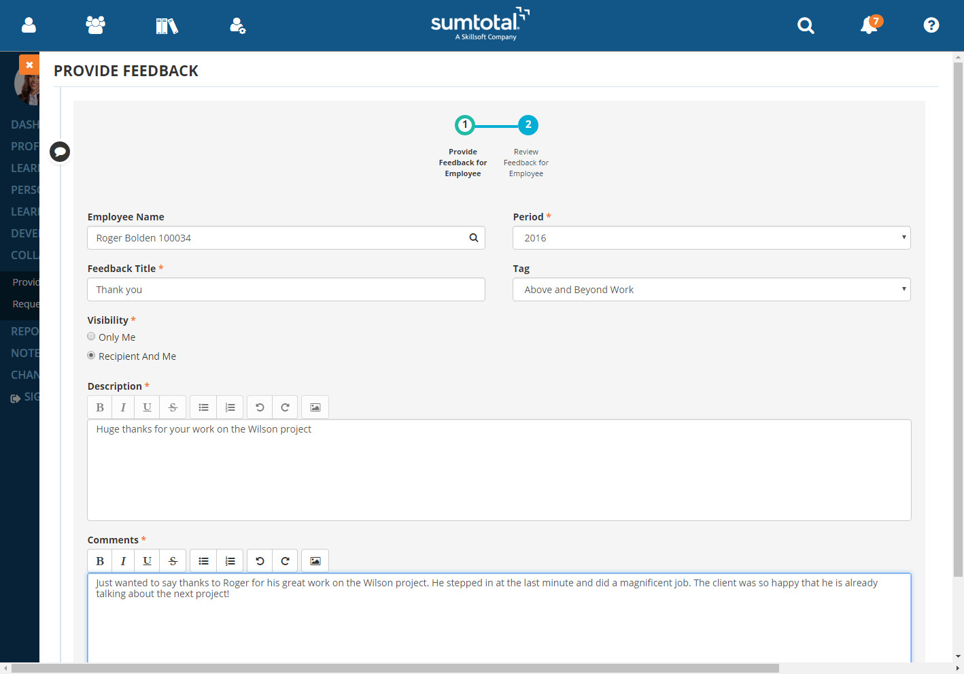

Sample LinkedIn Article: How Big Data can improve learning at work and the performance of your people

October 21, 2015

The Growth of Big Data
- Sales teams are using it to create methodologies to target high-value prospects, keep existing customers on board, and expand existing opportunities.
- Marketers are using it to create more personalized, targeted communication for better cut-through.
- Ecommerce sites, like Amazon, are using it to make better product recommendations.
- HR professionals are using it to make better hires, monitor performance, build better teams and create a strong leadership pipeline.

Big Data and Enterprise Learning
I've spent the last 30 years helping technology companies grow through presales, product and digital transformation. More recently I've been building AI-enabled services and exploring how AI will reshape business models. I'm looking for a leadership role where I can combine commercial strategy, technology and AI to help an organisation create something genuinely new.
Why Tym? There are plenty of AI specialists and plenty of technology executives. There are very few people who understand enterprise technology, can build products, lead customer-facing teams, sell at executive level and translate AI into practical business value. That's where I fit.

I've spent 30 years helping technology businesses grow. I've led presales, product and transformation teams across software, SaaS and managed services. What interests me now is helping an SI evolve from selling technology projects to delivering AI-enabled business outcomes. I understand how to build services, enable sales teams, work with vendors and take new offerings to market.
I build high-performing presales teams that don't just support sales—they shape strategy. My background spans integration, cloud, cybersecurity, data and AI. I've scaled teams, improved win rates, built repeatable assets and increasingly used AI to transform how proposals and customer engagement are delivered.
I've spent most of my career sitting between customers, sales, product and delivery. I enjoy translating complex technology into commercial outcomes. More recently I've focused heavily on AI, not simply as a product feature but as a capability that changes how organisations operate and compete.
My experience naturally evolved from presales into product because I enjoy creating new offerings. I've built AI-enabled services, worked across integration and cloud platforms, and understand how to take an idea from concept through to market adoption.
Many mid-market businesses know AI will change their industry but don't know where to start. I help executive teams identify practical opportunities, prioritise investments and execute change. My focus is not innovation theatre. It's delivering measurable commercial outcomes while managing risk.
Governments face the challenge of delivering better services with constrained resources. My background combines enterprise technology leadership with practical experience implementing change across complex organisations. I'm particularly interested in using AI to improve citizen outcomes while maintaining strong governance.
I help organisations answer three questions: Where can AI create value? How do we implement it safely? How do we turn it into a repeatable capability? My experience spans strategy, customer engagement, product development and delivery, which lets me bridge the gap between vision and execution.
I advise leadership teams on technology strategy, AI adoption and commercial growth. My perspective comes from three decades of helping organisations navigate major technology shifts, build new capabilities and align technology investments with business outcomes.
Healthcare is one of the sectors where AI can have the greatest practical impact. My background in enterprise technology, integration and organisational change positions me to help healthcare organisations modernise operations, improve service delivery and adopt AI responsibly.
Why:
My strengths align with:
I am more a business-oriented CTO rather than a pure engineering CTO.
Many organisations are looking for someone who can:

I enjoy both product mgmt and presales - and actually see them as two sides of the same coin, because both roles need to work with customers to identify requirements and build & sell a solution that meets those requirements.

If pressed, I'd probably say I prefer presales, but thats probably only because I've found it to be more lucrative. 😂

Tym would be well suited for a senior role at a services or consulting firm. He's has over two decade's experience in positioning, selling and leading digital technology and transformation projects.

He's worked for vendors like TIBCO, SumTotal, Zuora and Vignette, as well as customers like Macquarie Bank and Telstra. At these companies he's designed, built, sold or implemented an array of technology including analytics & data science, data management, integration, process automation, human capital management, document & content management, trading, ecommerce, billing and marketing solutions. He's done this for multiple industries like finance, telco, retail, utilities, health, transport & gov.

Importantly, he has both sales and implementation experience. As a presales director, he builds and maintains strong relationships with customers, creates & executes sales and marketing strategies and also acts as a thought-leader and presenter.

Bachelor of Law from UNSW with focus on IP and Internet Law

When I was younger, I read "Zen and the Art of Motorcycle Maintenance", a book which added to my desire to own a motorcycle. Now that I do, I love riding around the beautiful countryside of NSW in Australia.
Of course, like any other vehicle, I need to register my bike each year... in my case before Jan 30th. As my bike is now more than 5 years old, I had to take it to my local motorcycle service centre for the required eSafety check (or pink slip as it was once known). Once this was done, the service centre sends the report to Transport for NSW (TfNSW) electronically... something that's been in place since 1999!
Then, I had to renew my compulsory third party (CTP) insurance. Due to some changes to my situation, I called my insurer, GIO, to make a few edits to my policy, including where the bike was garaged. The friendly lady who answered my call couldn't update the garage location because they get that data directly from Transport for NSW.
So, I then logged into Service NSW and updated my residential address. Within seconds, GIO had the updated residential information and could adjust my CTP policy, which I then paid. After thanking the GIO service representative, I went back to Service NSW to see this...
Transport for NSW had everything they needed to renew my registration - which I did in just a few clicks. It was so easy, I felt immensely satisfied and at peace - almost zen-like.
This all seems so normal to most of us, but, really, its a wonder of the modern world.
When I was younger, this would have required multiple phone calls, posted letters or visits to a service centre where you had to wait in line for your turn.
If you stop to think about it, there is an amazing number of connections and secure integrations that need to work seamlessly, in real-time, to make it possible.
What makes me proud is that my employer, TIBCO, is the platform that makes many of these integrations possible. For example, it's public information that TIBCO provides integration services for Transport for NSW. We also power integration and API management solutions for a large number of Australian insurance & banking companies.
So, next time you benefit from the seamless software connection between organisations, stop to think about what it takes to make that happen. And, if you are an organisation that is struggling with integrations (or just managing your data in general), feel free to contact me or TIBCO.
This year I’ve been talking a lot about why annual performance reviews are on the way out when it comes to talent management.
Put simply, current approaches are time-consuming but don’t produce the desired outcomes.
The best replacement for the days of old school performance management is of course a continuous feedback model - the idea being that frequent communication, in real time, will produce positive change because potential problems are never allowed to simmer. But simply switching from one model to the other won’t necessarily guarantee a better outcome.
It’s one thing to have regular conversations and offer ongoing feedback, but it’s what you do with that knowledge that counts.
So how do you ensure your continuous feedback model really works?
You need a fully integrated Talent Management system which combines recruitment, learning and performance management into one suite. This enabling organisations to automate and optimise their performance processes and align employee development and goals with corporate objectives.
Once you have this, it’s far easier to implement best practice. SumTotal has produced an excellent white paper presenting ‘5 tips to Effective Performance Management’, including some sound advice for managers and HR professionals on processes you might like to incorporate into your continuous feedback model. The tips include:
If you’re interested in reading these tips in-depth, you can download the free whitepaper here.
Conclusion: Don’t rush into a continuous feedback model without a good framework in place. Invest in the methods and tools that will give you the most powerful insights and make the process as effective as possible.
Mother’s day in Australia is coming up on May 9th and this got me thinking.
My wife and I are parents to two boisterous sons, aged 7 and 9. Like most brothers, they’re occasionally squabbling and getting into trouble.
Can you imagine how things would go if mums and dads only gave their kids performance feedback once or twice a year?
I shudder at the thought.
Instead, like all parents, we try to make sure our children receive positive reinforcement soon after they have done something praise-worthy as well as suggestions for improvement when the opposite is the case.
In my role at SumTotal (a Skillsoft company) I also manage a team of highly skilled Solution Architects across Asia Pacific. Now, I’m not suggesting treating employees like children, but it is true that employees will also benefit from continuous and ongoing feedback that is delivered in a way that helps them develop and grow personally and professionally.
More focused and frequent performance reviews are important to employees’ ongoing career development, and research suggests they can be significantly beneficial to organizational performance too!
Employees are an organization’s greatest competitive advantage, however the systems many organizations are currently using to measure employees’ performance – the annual performance review - doesn’t produce the desired outcomes.
In many cases ‘annual performance reviews have not kept pace with today’s fast-paced business environment. Hence, business leaders are starting to question their effectiveness and overall value to the organization.
Annual performance reviews were first developed to set learning and development plans for the employee. They can be helpful to employees’ considering the possible career pathways within the organization, and provides a formal opportunity to reward staff.
Unfortunately, according to recent research conducted by CEB, more than 9 in 10 managers are displeased with how their organization conducts annual performance reviews, while 9 in 10 HR leaders believe the process does not yield accurate information. They are time consuming, with managers spending an average of 210 hours a year managing and conducting performance management activities.
Consider too the impact of workplace demographic changes. Millennial employees will represent 20 per cent of the workforce by 2020. There are many research studies out there which have shown that alongside remuneration benefits and flexible workplace practices, employees today – particularly Millennials - want to see their employer ‘investing’ in their professional development. According to a study from Robert Half, 82% of employees would like to discuss their career path one to four times a year. Currently 40 per cent of managers are not discussing an employees career path at all.
Some organizations are taking a new, fresh take on the performance review.
Examples include Accenture and Deloitte Australia, which are instead harnessing technology to provide more regular employee evaluation and feedback. HR technology has enabled more immediate insights into talent development, and we expect that moving forward – more organizations will follow suit to help their organizations become Self Developing.
In fact, it’s crucial that employers make adjustments to their assessment models; communicating more frequently, in real time to produce real positive change for long term gain.
For employees, the benefits of feedback is more impactful when feedback is continuous and timely. It enables accurate goals to be set - aligned to real work pathways, greater flexibility around processes, and a platform to give ‘kudos’ and provides ‘organization-wide’ recognition at the time of action, to reinforce strengths.
Utilizing HR technology to provide continuous feedback also has extensive benefits for HR professionals and managers:
In the future, successful organizations will make continuous learning and development a key selling point and source of strategic differentiation. They will need to become Self Developing Organizations in order to ‘win’ on talent. Talent management is crucial to any organization’s success, yet many organizations are failing to do it effectively. The fact is, processes that worked once, may not work now.
As part of the Solutions Architect team at SumTotal, I have seen more business leaders recognize that in order to stay competitive, their organization must use technology to evolve and innovate. When it comes to providing employee feedback on performance or projects, they must embrace ‘continuous feedback.’
This is why I’m so pleased to see the continuous feedback capabilities of the SumTotal Talent Expansion Suite Winter 2016 release - one example of which is seen in the image below.
This set of functionality allows people to easily request and provide ongoing feedback, which can be viewed at any time and also made available when doing a more formal annual performance review, if you still choose too.
It makes it easy to give ongoing performance feedback, just like a parent would.
To learn more about this feature and other parts of the SumTotal Talent Expansion Suite, why not join us for the upcoming webinar on Individualized Development? It’s on at 10am Australian Eastern Time on May 19th, 2016.
Hope to speak with you then. In the mean time, get something nice for mum. She's always looking out for you and trying to make you better. Just like a good manager would.
Years ago, when I got to the 4th or 5th stage of the recruitment process with Google, they asked me a brain teaser in the interview. I had to work out approximately how much storage space would be needed to store all the images used for Google maps. Prior to that, they had also asked me to send them my university transcript. Today, I understand Google will do neither of these when recruiting. Do you know why?
Technology has been a huge driver for business innovation over the last couple of decades, and this won’t change any time soon. It’s had an incredible impact on the way we work (and live), improving efficiencies and creating entirely new business models.
Big Data – the analysis of extremely large data sets to reveal patterns, trends, and associations – is a technology that is driving some of the most fundamental changes. Many of today’s most forward thinking businesses are looking to harness the power of Big Data to deliver substantial benefits across the business.
At the most fundamental level, Big Data is being used for more accurate forecasting and to make strategic business decisions, supplanting ‘gut feel’. Some examples:
The last point is precisely what has happened at Google. Their analytics showed that “brainteasers are a complete waste of time” and that university marks “did not correlate to success on the job”, so Google stopped using them - although not soon enough to help me.
We know that human talent is the key competitive edge in business, and we also know that you can’t hire yourself out of a skills crisis, so the only option is to invest in the development of your people via enterprise learning and talent management solutions.
Interestingly, when reviewing the research on the use of Big Data in the talent and HR space, I noticed that there wasn’t much information on the use of Big Data technology to improve enterprise learning and, ultimately, the performance of your people.
In the education space, Khan Academy is often upheld as a leader in the use of learning analytics to develop successful learning modules. Every day, it collects around 8 million data points on exercises and video interactions, and a few million more around community discussion, computer science programs, and registrations. From the data, it creates more personalized learning paths for each individual user. Learning content is not provided in a packaged textbook but is rendered or computed ‘on the fly,’ providing each learner with resources relevant to his or her profile, learning goals, and the knowledge domain the learner is attempting to master.
At Skillsoft we looked at our 19 million users across 60,000 learning assets – almost 1 trillion data points – and knew that we could do what Khan Academy has done, but for enterprise learning. So working with IBM Research we’ve applied its Big Data analytics and Natural Language Processing (NLP) technologies (which also powers the Jeopardy-winning Watson software) to Skillsoft’s learning content, user interactions, job roles and talent profiles. Using the insights from that data, we are creating new methods of developing and assessing optimal learning experiences to generate hyper-personalized learning paths for employees.
The possibilities are really exciting. We’ve already been able to produce algorithms to predict optimal engagement times, a content recommendation engine and a visualization framework to provide the foundation of a next-generation adaptive learning solution. With these assets in place, companies will be able to increase training utilization and completion rates through more targeted learning and improved engagement.
Data-driven learning is something that is expected to become mainstream in the next two to three years. By starting now, we have a fantastic competitive edge because every day, the data we use gets richer and the system continues to learn and evolve.
I'm facilitating a series of roundtables on "Leveraging technology and big data to provide individualized learning journeys" between 11:15am and 1:30pm on Wednesday 28th November at the HR Tech X / Learning@Work conference in Sydney, Australia.
If you would like to take part in the conversation and hear more about how others are leveraging big data technology for enterprise learning, I hope you can attend.
Of course, you’re also welcome to drop by and have a chat. I’ll be at the Skillsoft stand (#28) in the free exhibition area.

Learn More

The Economics of E-Loyalty – Harvard Business School (Fred Reichheld, Phil Schefter), 7/10/00
2017 Global Customer Experience Benchmarking Report – Dimension Data (member of NTT Group), 4/4/17; Includes 1,351 organizations across 80 countries.
2017 Customer Service Barometer – American Express, 12/15/17; random sample of 1,000 US consumers aged 18+ (overall results have a margin of error of +/- 3.1 percentage points at a 95% confidence interval

